# System Performance and Flux Calibration

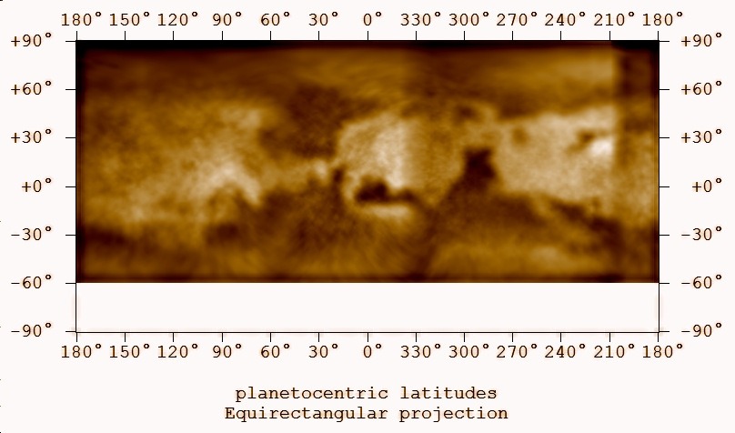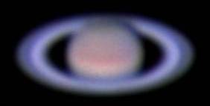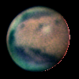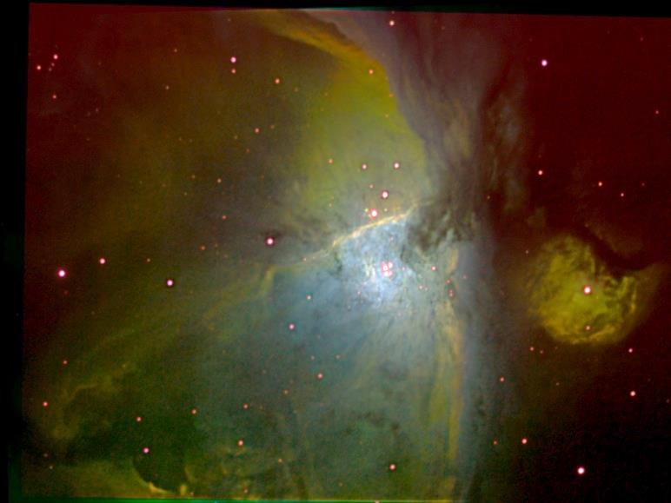

System Performance and Flux Calibration 1

Introduction 3

Celestron 8 and ST2000 Performance 5

Measured Performance 5

Modeled Performance 6

Response at Spectral Lines and Windows 7

Response with Filters 7

Filter Relative Response and Transmission 8

Filter Applications – Updated 5/31/2019 10

Filter Transmission 15

SBIG Broadband Filter Discussion 15

Narrow Band Emission Line Filter Discussion 16

380NUV Filter – Astrodon 17

UV and Blue Regime Filters 20

450BLU Filter – SBIG Blue 20

486HIB Filter – Baader Planetarium 8.5 nm 21

Green Regime Filters 23

501OIII Filter – Baader Planetarium 8.5 nm 23

550GRN Filter – SBIG Green 25

550CLR Filter – SBIG Clear 26

Red Regime Filters 27

650RED Filter – SBIG Red 27

656HIA Filter – Baader H-alpha 7 nm 29

658NII Filter – Astrodon NII 3.0 nm 33

672SII Filter – Baader Planetarium 8.0 nm 37

NIR Regime Filters 41

685NIR Filter – Baader 41

742NIR Filter – Astronomik 44

807NIR Filter – Astronomik 45

889CH4 Filter – Methane, Model, etc… 46

Other Filters 49

Lumicon Deep Sky Filter 49

Appendix: Optical System Details 50

Celestron 11 52

Celestron 8 53

Takahashi TKE Epsilon 130 57

Pentax 135mm Lens 57

Appendix: Camera Response 58

Camera Comparisons 58

ST2000XM Model Data 59

ASI120MM – ZWO Source Data 63

Canon EOS Rebel 500D 67

ToUCam 840K 67

Appendix: SBIG Filter References 68

Appendix: Atmospheric Transmission 70

Appendix: Math Stuff and FWHM to EW 72

Bibliography 73

## Introduction

This document should be broken into at least three documents as of 5/4/2018 due to overall complexity. First, there is sufficient information to assemble a report on ST2000XM performance, both modeled and measured. That document can indicate adopted performance. Second, there is sufficient information to assemble the definitive performance of the red narrowband filters (HI, SII, NII) and also possibly the red broadband filter. Third, there is sufficient information to establish C8 throughput. Finally, it should be possible to establish the overall system performance, both with clear filters and with red region filters.

Remaining work on the red filters includes:

1. Collecting the older analysis done on filter shape with Jovian moons (in that project directory),
2. Doing a best fit relative photometry using M42 and M33 field stars to establish relative equivalent width.
3. Using manufacturer data on peak transmission to establish true shape of the filter transmission, either using a Gaussian function or by scaling the manufacturer transmission shape to meet the peak and EW observed.

The main point here is to remember that the reason I’m doing this is not to rewrite code (which is useful), but to establish filter ratios for continuum subtraction and line subtraction so I can to nebular plasma analysis.

The motivation for understanding system performance is to provide spectrophotometric calibrations for astronomical observations so that physical quantities can be retrieved. Short of full spectrophotometric characterization, relative calibration of spectral bands can be very useful as well.

To achieve either goal there are two sources of available data. First, there is manufacturer data. Unfortunately, this data usually pertains to ‘typical’ performance of the given system element rather than the performance of the item purchase. It is however, a good first starting point. Second, measurements of known sources with the system can be made, e.g., calibration stars. These measurements can be photometric, e.g., capturing the entire performance of a given spectral passband. Or, they can be spectrometric, e.g., capturing the relative spectral response within the spectral passband.

## Celestron 8 and ST2000 Performance

This section describes the relative spectral response of the Celestron 8 – ST2000XM observing system. First, system-level measurements that were made by observing astronomical reference objects with *StarAnalyzer* 100 lines-mm-1 and 200 lines-mm-2 gratings are described. Second, performance is modeled on available literature regarding equipment and atmospheric transmission. Third, the mean response as spectral lines and spectral windows of interest are computed based on the measured data. Finally, the performance of the system is computed with various filters in the optical train based on detailed filter models and data discussed later in this report.

### Measured Performance

Spectral response measurements of the ST2000 have been made using four system configurations (Figure 1). Two sets of optics were used: the 135mm lens and the C8. For each set of optics, spectra were taken with both the 100lpm and 200lpm Star Analyzer gratings. The star Vega was used as the target. Either no filter or a clear filter was used for the measurements, so they cover the full spectral range of the system.

The response files, in *.txt format, reside in the */1D Spectra* folder of the star Vega. They were generated by the *SpectralProcessingScript.py* spectral analysis codes[1]. Then, the responses were read and analyzed by *SystemResponse.py[2]*. It provides functions like averaging, error analysis, and equivalent width determination. Where there were multiple measurements made in some configurations, the 95% confidence error bounds are computed.

Manufacturer quantum efficiency (QE) was available for the ST2000 (see Appendix: Camera Response). The data were exported from the spreadsheet to a CSV file, *CameraResponse-Sheet1.txt*, to be read into *SystemResponse.py,* normalized, and plotted with the measured relative spectral data. Since the normalized QE represents response to photons, I also convert to relative energy and normalize it.

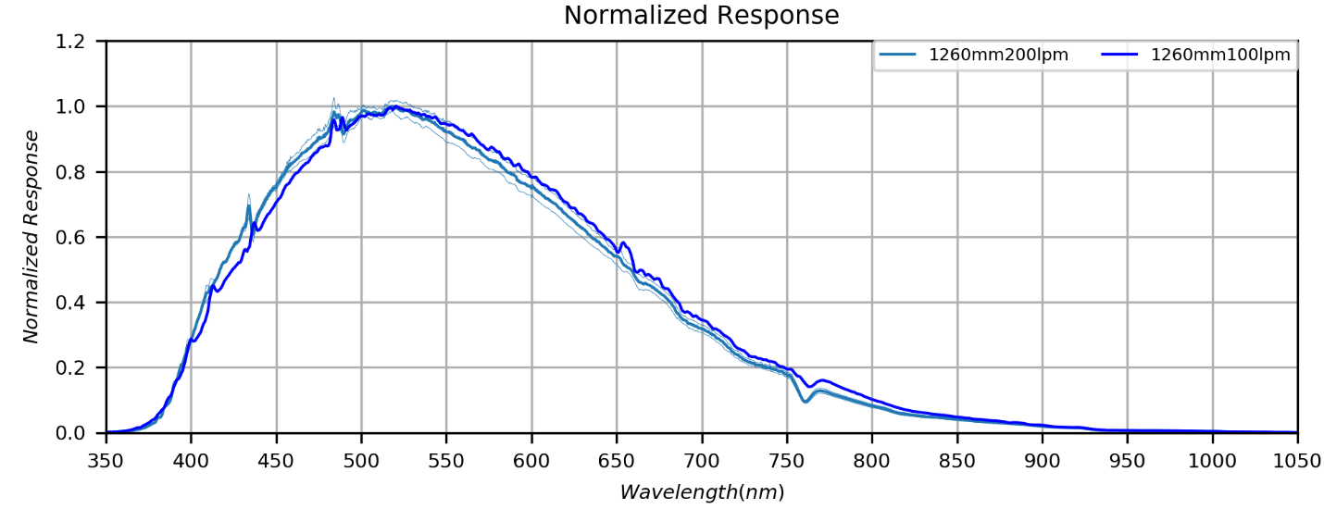

Figure 1: ST2000 response with the Celestron 8 telescope. Confidence intervals (95%) are shown where multiple measurements are available. (Response1260mmCLR-Measured.png)

There are two notable features to measurements shown in Figure 1. The first is the set of remnant artifacts from individual stellar and atmospheric absorption features. Since Vega, and A0 star was used for the calibration, there are strong hydrogen Balmer lines. The remaining artifacts are due to slight wavelength calibration errors and slight differences in spectral resolution and sampling between the reference spectra and the observational spectra. While the uncorrected stellar artifacts represent errors, the atmospheric absorptions are real and can be dependent on atmospheric conditions.

The second is that the 135mm camera lens has poorer response in the blue and better response in the red than the C8. The difference can be attributed to the different optical elements involved in each lens. This effect is not too significant in the visible range, but it is important in the NUV and NIR regions.

### Modeled Performance

Overall system performance was modeled using the best available manufacturer data and environmental models. These include Celestron 8 transmission, ST2000XM quantum efficiency, and atmospheric transmission. The individual models are detailed in the Appendices of this report.

First, the relative system performance measured in the blue spectral region is much lower than the camera response curve. This would account for about half of the difference between camera response and system response.

While I was unable to locate information on Celestron 8 spectral transmission for my generation of C8, I was able to find the data for later generations (see Celestron 8 section). These data appear to account for the remaining difference. It should be noted that these data don’t account for additional optical elements like Barlow or reducer lenses, which would further reduce the blue transmission.

Finally, the grating used for the measurements will have some spectral dependence. The only way to address that issue is to compare the spectral response to filtered photometric responses.

The *SystemResponse.py* software also generates estimates of relative sensitivity to a uniform white source of radiation at certain wavelengths or windows of interest. That data is compiled in Table 1 from the files *135mm100lpm-550CLR-EW.txt* and *1260mm200lpm-550CLR-EW.txt*. The wavelengths represent either emission or absorption lines and the windows represent broadband filters.

### Response at Spectral Lines and Windows

Table 1: Relative response of various optics-filter combinations. (ResponseCalibrations20180208.xlsx)



The average response at a line or for a window is computed is computed as:

The values of λ0 and λn are selected to cover the majority of the flux contributing to a window. For a line, they are chosen to be 1 nm wide. THIS IS PROBABLY A BAD IDEA. TOO MUCH DEPENDENCE ON ONE OR TWO SPECTRAL BINS. NOT ONLY THAT, BUT ARTIFACTS FROM THE LINE IN THE MEASURE SPECTRA MAY HAVE A SIGNIFICANT EFFECT.

### Response with Filters

TBD

## Filter Relative Response and Transmission

Spectra were taken of several well characterized sources (Aldebaran, Rigel and Capella) through broadband color filters from the NUV to the NIR. These data were taken using the 135mm lens with the 100lpm grating. The response curves generated by the *SpectralProcessingScript.py* spectral analysis codes result in profiles with the peak normalized to unity. To overlay the filter responses with the clear filter response (Figure 2), each filter curve was multiplied by a scale factor determined visually.

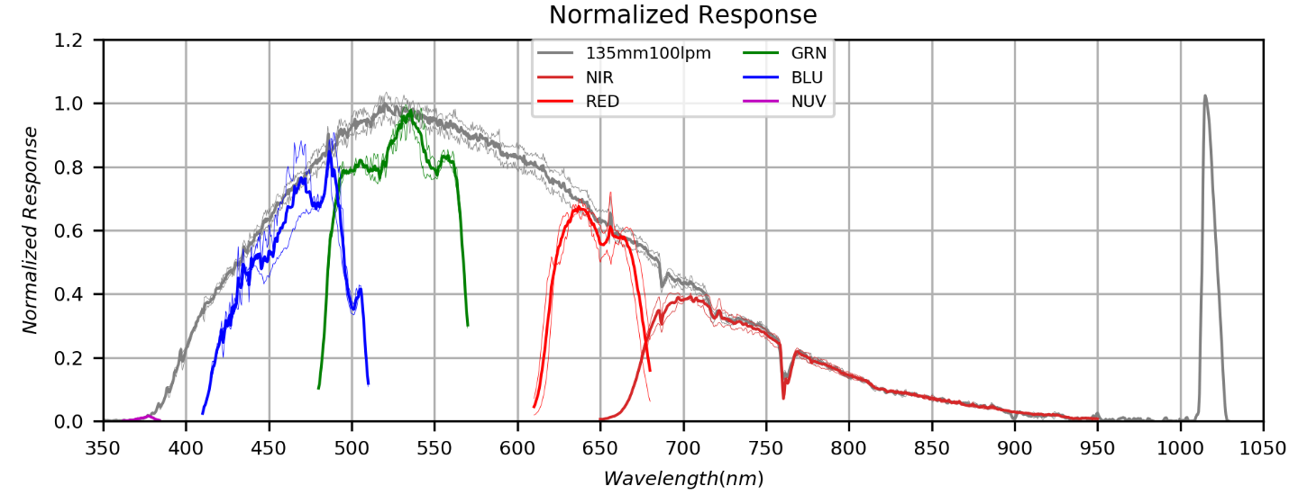

Figure 2: ST2000 response with broadband filters. (FilterRelativeSystemResponse.png)

(MeanNIR,0.40,'C3','NIR')

(MeanRED,0.690,'r','RED')

(MeanGRN,0.980,'g','GRN')

(MeanBLU,0.875,'b','BLU')

(MeanNUV,0.016,'m','NUV')

Table 2: Relative Response with Different Grating and Filter Combinations (ResponseCalibrations20180208.xlsx)

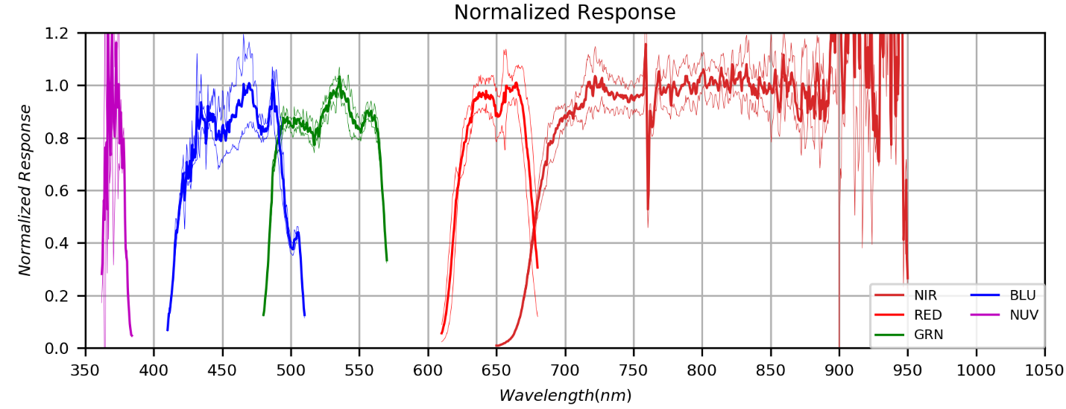

FilterTransmission.png (Maybe add all the info I have for the narrow band filters also, or make a separate plot with only narrow band data.)

## Filter Applications – Updated 5/31/2019

Table 3: Filter Applications (FilterApplications.xlsx).



Comet lines:

CN band heads: 388.3, 421.6, red and NIR bands I don’t understand

C3: 405,

C2 band heads: 438.2, 473.7, 516.5, 563.5, 619.1

NH2 band heads: 570.0

MOVED THE BELOW FROM *OBSERVINGNOTES2015.DOCX* on 5/23/2019

So now I have HI, OIII and SI filters. A general ability to discriminate the ionization energy shows as a general rule OIII is the “hottest” and closest to the illuminating star followed by HI then SII. However, nothing quantitative regarding intensities can be done because of interstellar reddening and the fact that the HI filter is 7nm wide and includes both neighboring NII lines.

Current Filters (updated 2019):

|  |  |  |  |  |  |
| --- | --- | --- | --- | --- | --- |
| Band/Name | Lines | Center | FWHM | Manufacturer | Notes |
| HIα | 656.3 | ? | 7.0? | ? |  |
| OIII | 495.9, 500.7 | ? | 8.5 | Baader | Manufacturer data |
| SII | 671.7, 673.1 |  | 8.5 | Baader | Manufacturer data |
| HIβ | 486.1 |  | 8.5 | Baader |  |
| NII | 658.3 | 658.3 | 3.5 | AstroDon | Used |
| **Proposed** | | | | | |
| ***He II*** | ***468.6*** | ***470.0*** | ***10.0*** | ***Edmund Optics*** | ***Multipurpose: Good for relatively bright component of PNs, but also good for C2 Swan Δv=+1 band at ~470nm.$185.*** |
| ***[O I]*** | ***630.0*** | ***632.0*** | ***10.0*** | ***Edmund Optics*** | ***Multipurpose: PNs (faint line) and comets. $185.*** |
| ***He I*** | ***587.6*** | ***589.0*** | ***10.0*** | ***Edmund Optics*** | ***Multipurpose: PNs, comet continuum(?) and Na doublet (where?). $185.*** |
| ***Red Cont.*** | ***N/A*** | ***645.0*** | ***10.0*** | ***AstroDon*** | ***Red Continuum*** |
| ***CH4*** | ***619.0*** | ***620.0*** | ***10.0*** | ***Edmund Optics*** | ***Weak CH4 for Jupiter also Red(ish) continuum*** |
| ***S III*** | ***953.2*** | ***950.0*** |  |  |  |
| ***He I*** | ***587.6*** | ***589.0*** | ***10.0*** | ***Edmund Optics*** | ***Multipurpose: PNs, comet continuum(?) and Na doublet (where?). $185.*** |

Adding both HIβ and NII would in principle permit spatially resolved, quantitative measurement of interstellar reddening by comparing HIβ/HIα to the predicted Balmer decrement. This is predicated on the assumption that the NII 658.3 and 654.8 nm lines are populated by the same upper state and related only by a well-known branching ratio.

A user in Poland has done work with “exotic” narrow band imaging, including identifying sources for filter components. His main site is <http://www.rkblog.rk.edu.pl/w/p/helium-argon-and-neon-narrowband-imaging/>. The site with Edmund Optics components is <http://www.rkblog.rk.edu.pl/w/p/choosing-edmund-optics-filters-helium-oxygen-and-argon-narrowband-imaging/>.

The He II, He I and [O I] filters seem like nice additions to my set and some have multiple purposes. Note that it is possible to complement the 470nm filter’s ability to measure the C2 Δv=+1 band with a filter at 515nm to measure the Δv=0 band at 514nm.

Finally, I should not forget the use of NIR 10nm FWHM filters to look at methane band centers and wings of the outer planets.

Note that the user in Poland had an astronomical equipment vendor mount the EO filters in standard 1.25” filter mounts.

Spectrograph Slit sources (look for high-powered air slits for gold reflectivity):

<http://www.edmundoptics.com/optomechanics/irises-apertures/pinholes-slits/precision-air-slits/1845/>

<http://www.nationalaperture.com/reflective.htm>

<http://www.shelyak.com/recherche.php> (search “slit”)

Many spectrograph designs including a reflective needle slit:

<http://www.eyes-on-the-skies.org/shs/needle1.htm>

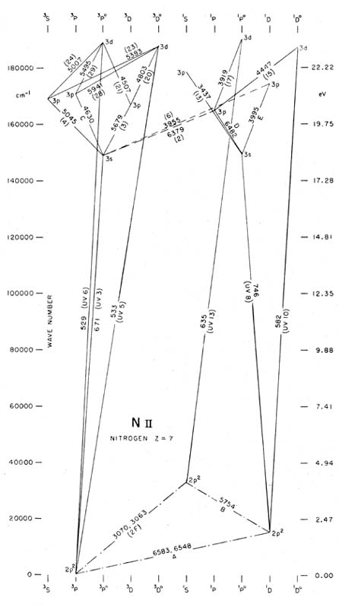

From: <https://ned.ipac.caltech.edu/level5/Ewald/Grotrian/n2.jpg>

Here it is assumed that the two lines of these doublets have relative strengths proportional to their Einstein A coefficients, or in this case 3:1. Thus Ι(λ6548 -l· λ 6583) = 4/3 Ι(λ 6583) and /(λ 6300 -h λ 6363) = 4/3 /(λ 6300). λ 3726 and λ 3729 of 0+ are measured as one line, the λ 3727 line.

**Above is from 1968PASP___80__689C.pdf in PN project references.**

Same value (3:1) can be found in <http://www.nist.gov/srd/upload/jpcrd3620071287p.pdf> on page 1342 in the ratio of the A values

Nice units conversion page: <http://halas.rice.edu/conversions>

## Filter Transmission

As of 2018-01-02 I’ve decided to break this section up a bit more. It will now have three subsections: SBIG Broadband filters, NIR broadband filters, Narrowband emission line filters, and Narrow continuum filters.

<http://www.reinervogel.net/index_e.html>

<http://www.samirkharusi.net/spectrograph.html>

### SBIG Broadband Filter Discussion

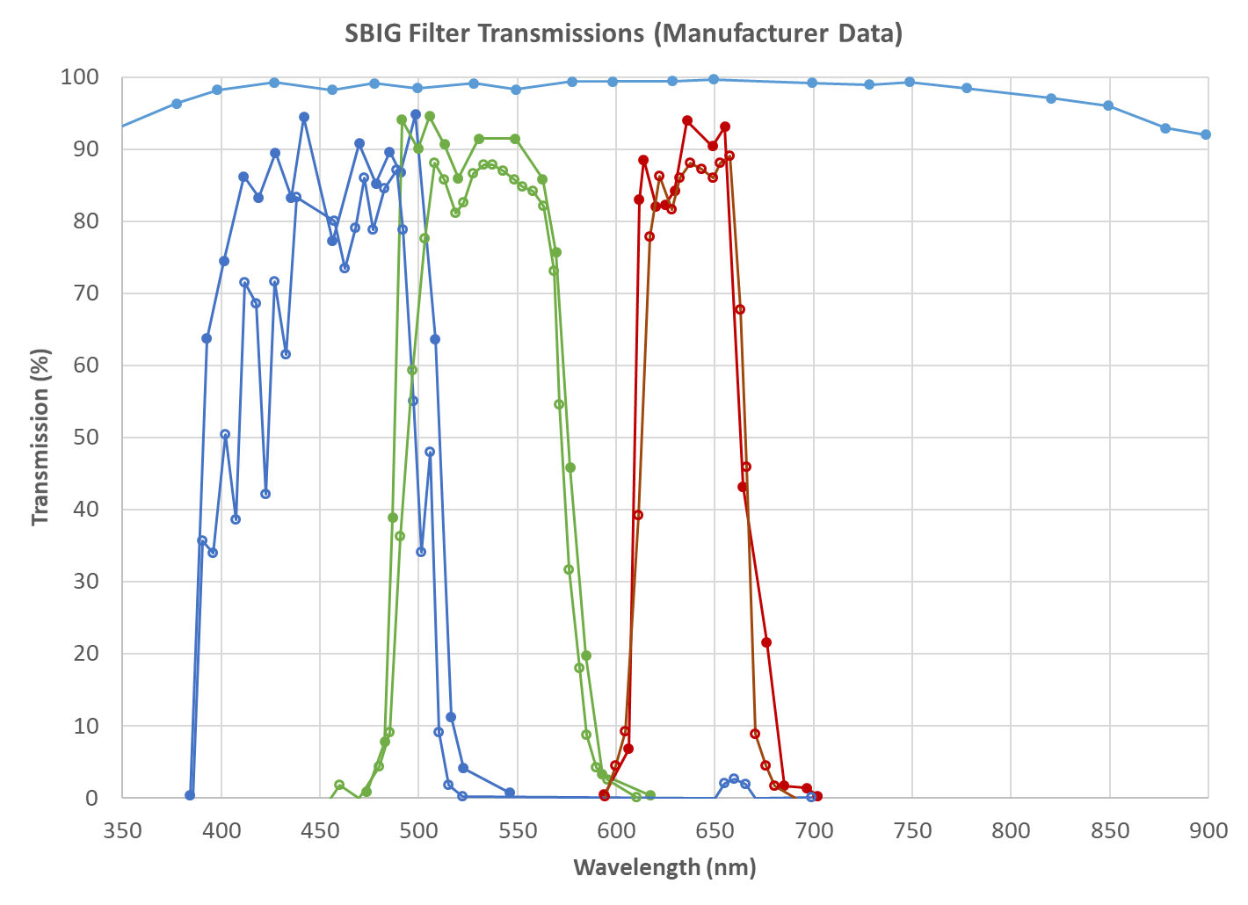

From: CameraResponse.xlsx

Not sure where to put this summary output from *Flux_Calibration_V001.py*.

|  |  |  |  |  |  |  |  |  |  |  |  |  |
| --- | --- | --- | --- | --- | --- | --- | --- | --- | --- | --- | --- | --- |
| **Target** | **Date-Time(UT)** | **Band Type** | **Band** | **Start(nm)** | **End(nm)** | **Cont(nm)** | **EW/Intensity** | **Peak** | **Center(nm)** | **Dispersion** | **Disp. Err.** | **FWHM** |
| RED | 2014-09-03 | Target | CH4 889 | 875.5 | 904.5 | 3.5 | -11933.4 | 1063.776 | 889.528 | 1.0382 | 0.0094 | 11.21798 |

### Narrow Band Emission Line Filter Discussion

What does the code do that’s different than the main FITS to spectrum code? Is it anything other than averaging? Is the spectrum divided by a G2V reference spectrum to obtain an albedo spectrum? Should these codes be merged?

**I believe the code that provides this output (EWs, ASCII spectra and EW data) is *FilterTransmissionfromFITS_V002.py.* Right now V002 does not fully execute, but V001 does. The codes need a lot of clean up and a response averager needs to be written. This would be a good candidate to move to the new Spectrophotometry repository.**

|  |  |  |  |  |  |  |  |  |  |  |  |  |
| --- | --- | --- | --- | --- | --- | --- | --- | --- | --- | --- | --- | --- |
| **Target** | **Date-Time(UT)** | **Band Type** | **Band** | **Start(nm)** | **End(nm)** | **Cont(nm)** | **EW/Intensity** | **Peak** | **Center(nm)** | **Dispersion** | **Disp. Err.** | **FWHM** |
| CH4 | 2014-09-03 | Target | CH4 889 | 875.5 | 904.5 | 3.5 | -11933.4 | 1063.776 | 889.528 | 1.0382 | 0.0094 | 11.21798 |
| HAL | 2014-09-03 | Target | 656HAL | 641.5 | 670.5 | 3.5 | -404663 | 36836.28 | 656.446 | 1.0421 | 0.0003 | 10.98544 |
| NUV | 2014-09-03 | Target | 380NUV | 360.5 | 389.5 | 3.5 | -13810.6 | 897.871 | 379.458 | 1.0600 | 0.0050 | 15.38152 |

Dispersion error between HAL and CH4 is minor, but does add up to ~3nm at CH4. Thus, it is probably representative either of non-linearity or of actual centroid offsets from the specified wavelengths. Looking at additional narrow bands along with calibration against known solar/stellar bands should resolve which type of error(s) exist in the dispersion and permit creating a more accurate general expression for dispersion.

The larger dispersion error for NUV, particularly the fact that it goes against a 2nd order trend, suggests an actual offset from my assumed centroid of 380nm. In this case, the centroid would be more like 372 nm. NUV is also particularly difficult because of the steep gradients in the source spectrum and detector response. So, it is not clear that we’ve isolated the filter transmission totally from these effects. For HAL and CH4, these gradients are much smaller.

## UV and Blue Regime Filters

### 380NUV Filter – Astrodon

Is the Astrodon UVenus filter the same as the Astrodon Sloan u’ filter? If so, there are more traces and measurements out there that could be used as baseline manufacturer data.

#### Manufacturer Data

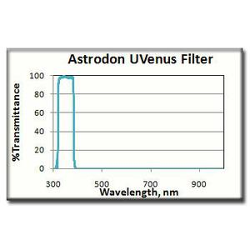

<http://www.astroshop.eu/astrodon-uv-venus-filter-1-25-/p,14692>

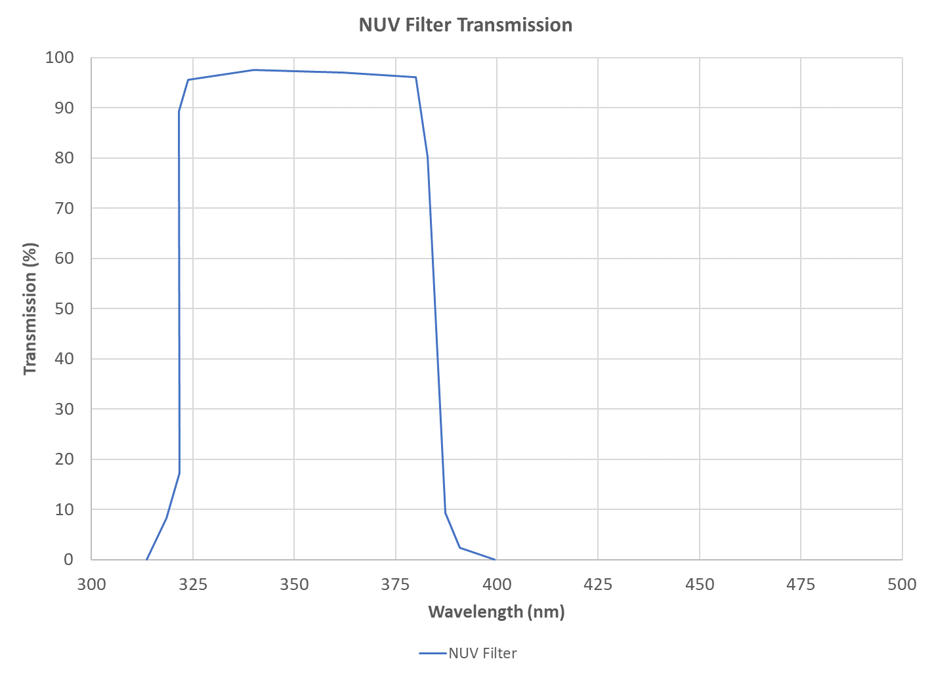

#### Measured Data

|  |  |  |  |  |  |  |  |  |  |  |  |  |
| --- | --- | --- | --- | --- | --- | --- | --- | --- | --- | --- | --- | --- |
| **Target** | **Date-Time(UT)** | **Band Type** | **Band** | **Start(nm)** | **End(nm)** | **Cont(nm)** | **EW/Intensity** | **Peak** | **Center(nm)** | **Dispersion** | **Disp. Err.** | **FWHM** |
| NUV Jupiter | 2014-09-03 | Target | 380NUV |  |  |  |  |  | 382.310 | 0.5515 |  |  |
| NUV Capella | 2014-09-03 | Target | 380NUV |  |  |  |  |  | 364.034 | 1.1095 |  |  |
| NUV Rigel | 2014-09-03 | Target | 380NUV |  |  |  |  |  | 361.496 | 0. 5523 |  |  |

|  |  |  |  |  |  |  |  |  |  |  |  |  |
| --- | --- | --- | --- | --- | --- | --- | --- | --- | --- | --- | --- | --- |
| **Target** | **Date-Time(UT)** | **Band Type** | **Band** | **Start(nm)** | **End(nm)** | **Cont(nm)** | **EW/Intensity** | **Peak** | **Center(nm)** | **Dispersion** | **Disp. Err.** | **FWHM** |
| CH4 | 2014-09-03 | Target | CH4 889 | 875.5 | 904.5 | 3.5 | -11933.4 | 1063.776 | 889.528 | 1.0382 | 0.0094 | 11.21798 |
| HAL | 2014-09-03 | Target | 656HAL | 641.5 | 670.5 | 3.5 | -404663 | 36836.28 | 656.446 | 1.0421 | 0.0003 | 10.98544 |
| NUV | 2014-09-03 | Target | 380NUV | 360.5 | 389.5 | 3.5 | -13810.6 | 897.871 | 379.458 | 1.0600 | 0.0050 | 15.38152 |

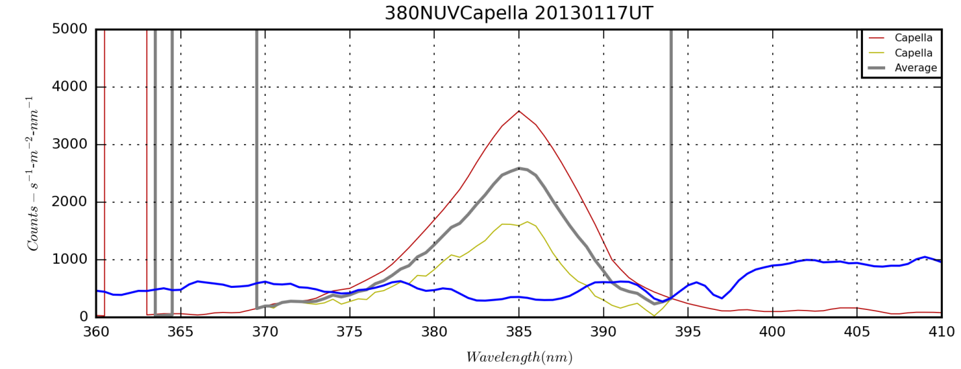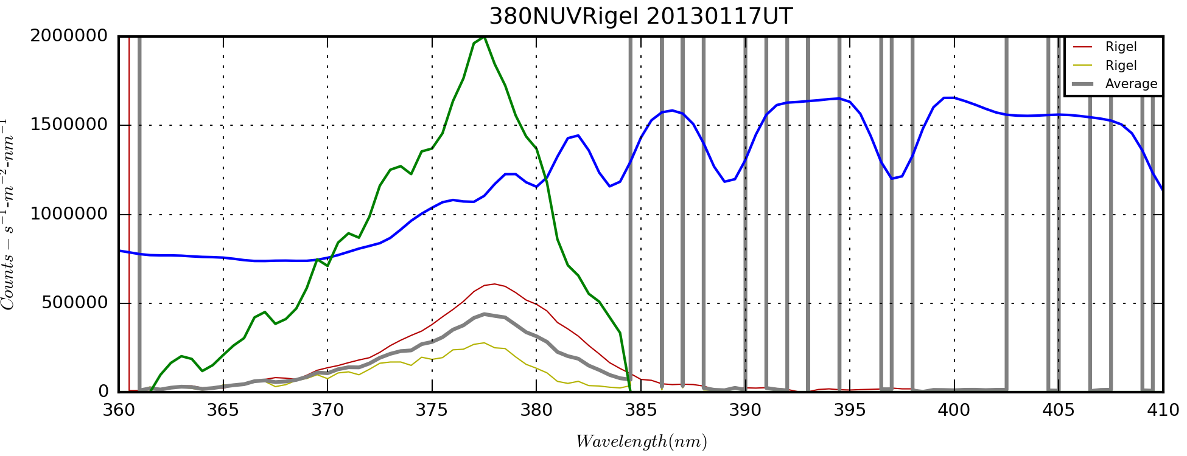

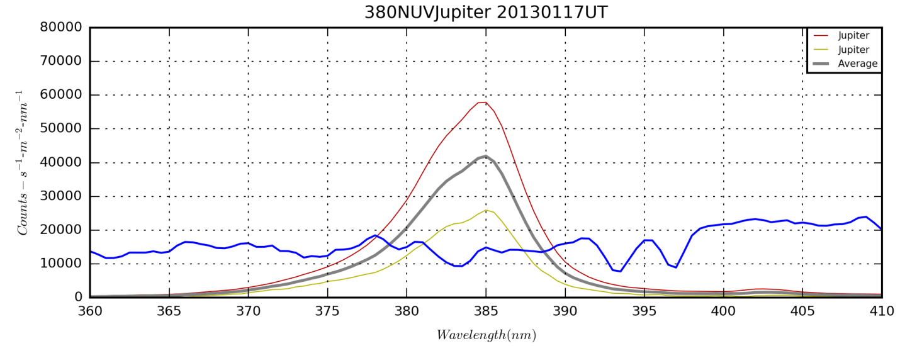

**NUV Filter – Make, Model, etc…purchase date, cost – older section?**

Should this go with the broadband filters? Probably. The narrowness of the plot is probably due to shortwave cutoff due the source and atmospheric absorption. Also, I’m wondering how I got the wavelength calibration here since the spectrum seems featureless. I may have simply used a computed calibration base on the dispersion for other filters.

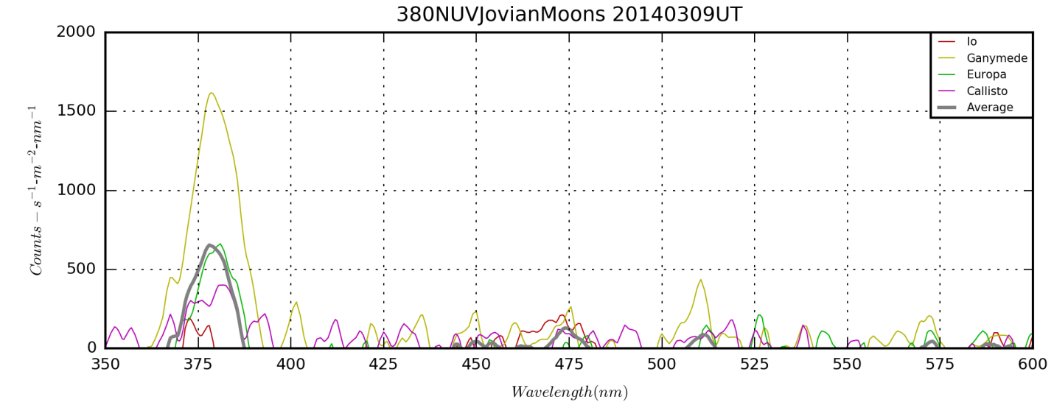

380NUV Jovian Moons NUV 20140309UT_1D.png from *FilterSpectumFromFITS.py*.

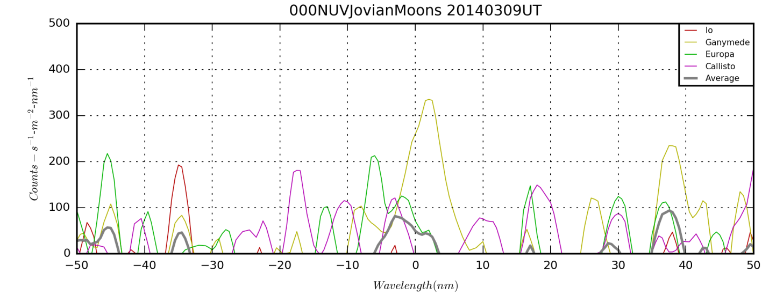

Dispersion = 1.060±0.005 nm-pix-1

### 450BLU Filter – SBIG Blue

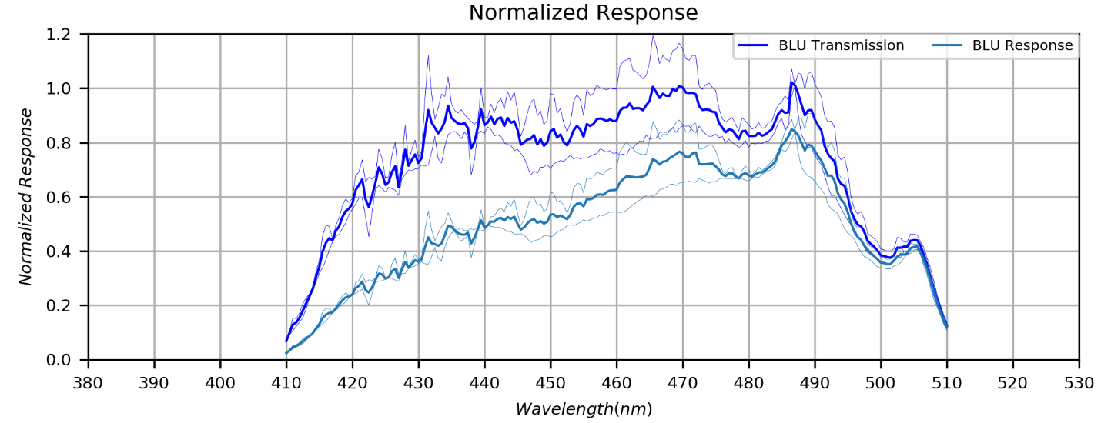

BLUTransmission.png

### 467HeII Filter – Edmund Optical 10 nm

### 486HIB Filter – Baader Planetarium 8.5 nm

#### Manufacturer Data

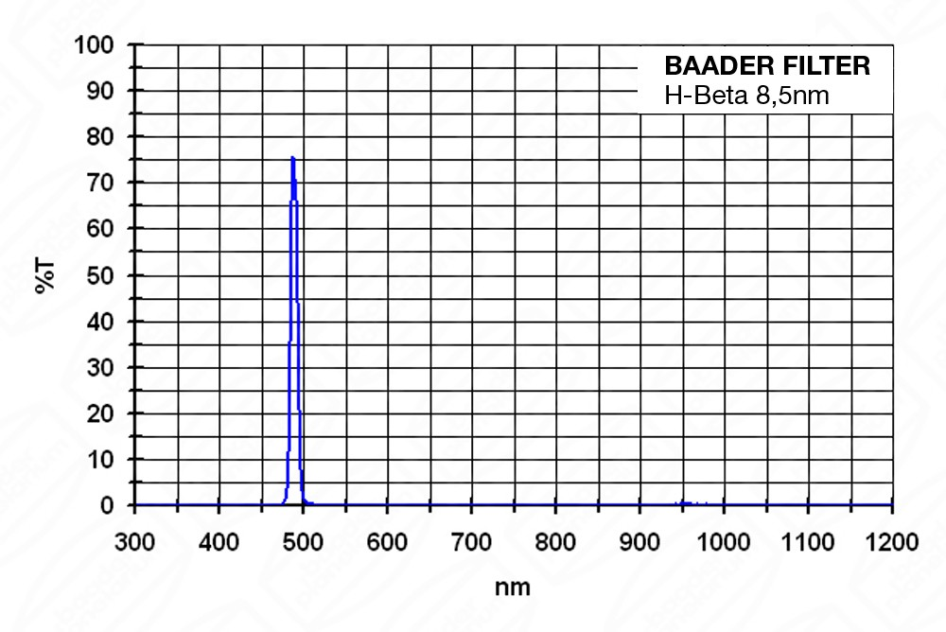

Figure 3: Transmission data from Baader website. (baader-h-beta-85nm-ccd-narrowband-filter-1-1-4--a06.jpg)

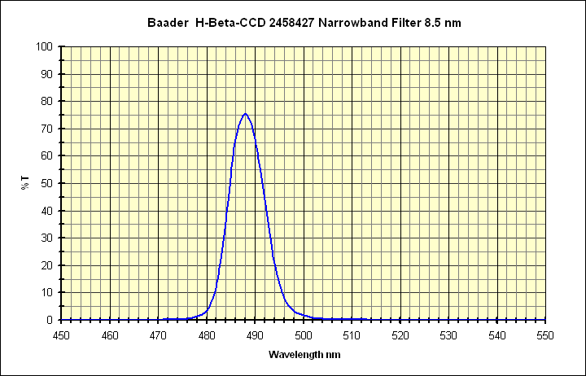

Figure 4: Transmission data from Company 7 website. (baader_h-beta.gif)

#### Measured Data

## Green Regime Filters

### 501OIII Filter – Baader Planetarium 8.5 nm

#### Manufacturer Data

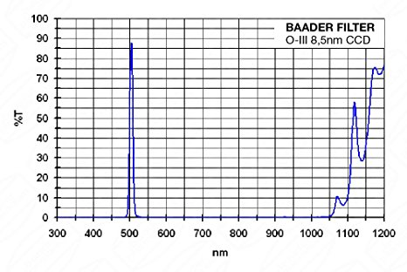

Figure 5: Transmission data from Baader website. (OIII-Baader-85nm.jpg)

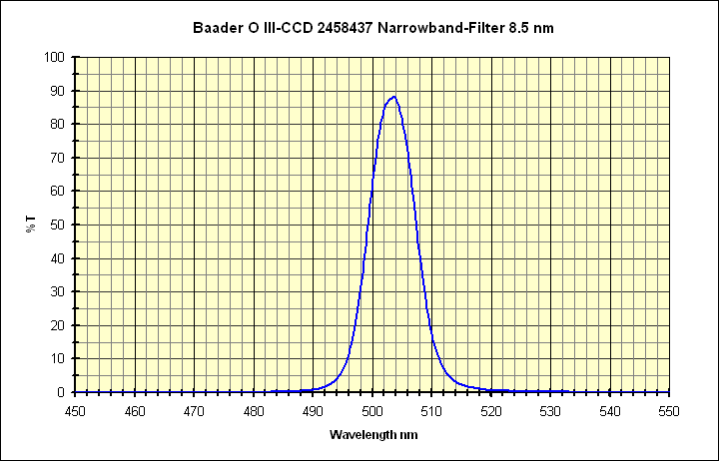

Figure 6: Transmission from Company 7 website. (baader_OIII.gif)

#### Measured Data

### 505C2 Comet Filter –Manufacturer?

### 540CNT Solar Continuum Filter – Baader Manufacturer? – 10nm?

### 550GRN Filter – SBIG Green

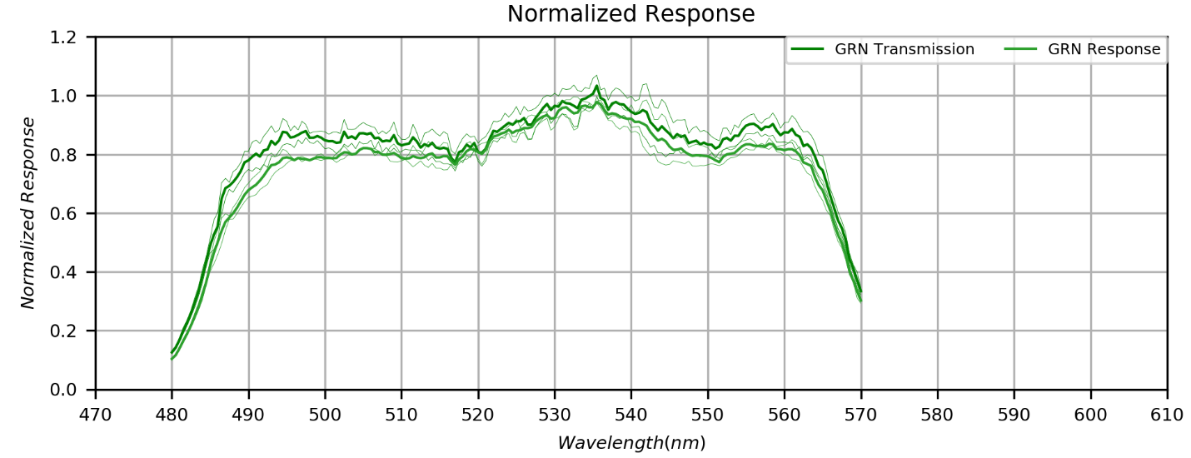

GRNTransmission.png

### 550CLR Filter – SBIG Clear

## Red Regime Filters

### 647CNT Continuum and NH3 Filter – Edmund Scientific 10 nm

### 650RED Filter – SBIG Red

The red filter used for imaging is the standard SBIG filter provided with the SBIG CW8 filter wheel. It is the version with the built-in UV and NIR rejection. The filter I have has a sliver of clear transmission around on edge of the filter holder.

#### Manufacturer Data

Data was found online in the form of two plots. Those plots were digitized using DataTheif and are shown below in Figure 1. The data from the two plots is similar in peak sensitivity and width, but there is a shift of about 5 nm between them.

Figure 7: SBIG red filter transmission measured from two on-line plots. (CameraResponse.xlsx)

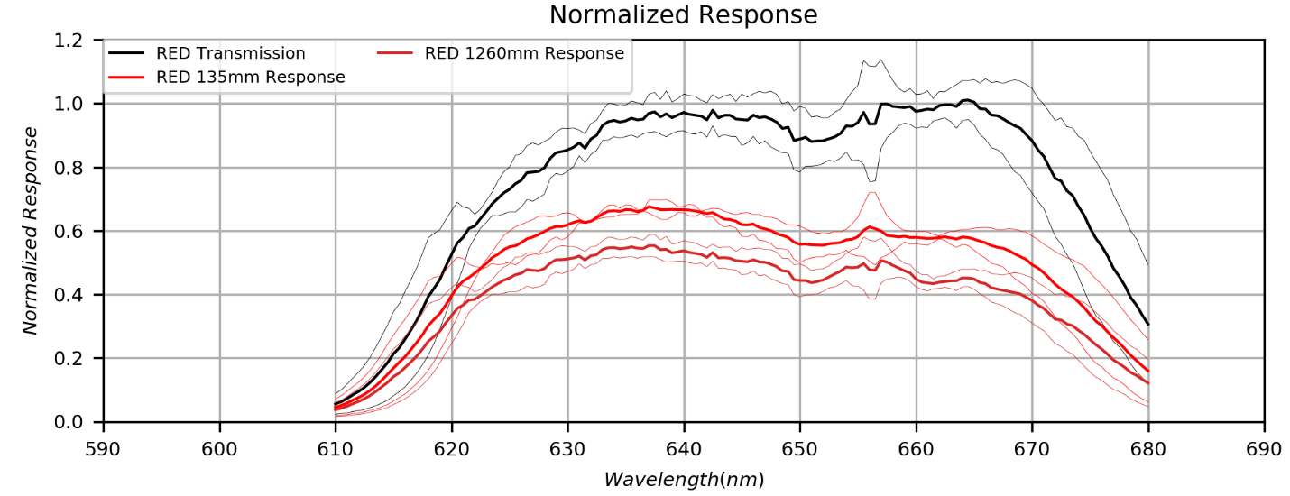

Figure 8: Measured transmission of the SBIG red filter, along with response curves when used with different optical systems. (REDTransmission.png)

Older work (needs references): From 610-685nm the average response of the **135mm-650RED-ST2000** system is 0.480 (normalized to the peak response of the 135mm-550CLR-ST2000 system). This gives an equivalent width of 75x0.480=36nm. Thus, the parameter $E^{650RED}=36.0nm$**.**

From 610-685nm the average response of the **1260mm-650RED-ST2000** system is 0.396 (normalized to the peak response of the 1260mm-550CLR-ST2000 system). This gives an equivalent width of 75x0.396=36nm. Thus, the parameter $E^{650RED}=29.7nm$**.**

Response of the narrowband filters within the bounds of the red filter are discussed below.

|  |  |  |  |  |
| --- | --- | --- | --- | --- |
|  | $$E^{650RED}$$ | $$s_{HIA}^{650RED}$$ | $$s_{NII}^{650RED}$$ | $$s_{SII}^{650RED}$$ |
| 1260mm 200lpm | 29.7 | 0.484 | 0.495 | 0.334 |
| 135mm 100lpm | 36.0 | 0.586 | 0.573 | 0.431 |

Further work:

1. Ensure that the minimum and maximum wavelengths for the integration and averaging extend all the way to the tails of the filter response.

#### Adopted Performance

Table 1: Models and Transmission Parameters.

|  |  |  |  |  |  |  |  |
| --- | --- | --- | --- | --- | --- | --- | --- |
| **Model** | **FWHM** | **Peak** | **Peak Wv.** | $$E^{650RED}$$ | $$s_{HIA}^{650RED}$$ | $$s_{NII}^{650RED}$$ | $$s_{SII}^{650RED}$$ |
| 1) SBIG Plot 1 | TBD | 0.94 | 635.8 | 52.3 | 0.87 | 0.80 | 0.29 |
| 2) SBIG Plot 2 | TBD | 0.81 | 657.6 | 47.9 | 0.88 | 0.87 | 0.08 |
| 3) Measured [1] | TBD | 1.00 | 664.3 | 52.9 | 0.98 | 0.98 | 0.75 |
| 4) Measured [2] | TBD | 0.88 | 664.3 | 46.6 | 0.86 | 0.86 | 0.66 |

[1] Data are transmission normalized to a peak of unity. Line transmission values are estimated from an interactive plot and visually smoothed over fluctuations due to noise and H-alpha artifacts.

[2] Data scaled by 0.88, the average peak of 1 and 2

Now need to apply (convolve or multiply as appropriate) clear response functions. From the **TBD** document we know the average response of the **1260mm-650RED-ST2000** system is 0.396 (*normalized to the peak response* of the 1260mm-550CLR-ST2000 system). So, multiplying by model #4 above is appropriate since it accounts for the fact that the peak response is in fact 88% of the clear response. Similarly, for the line emissions we have responses of 0.484, 0.495, and 0.334 for HIA, NII and SII respectively. Again, these assume that the red filter peak response was normalized to the clear filter response.

|  |  |  |  |  |  |  |  |
| --- | --- | --- | --- | --- | --- | --- | --- |
| **Model** | **FWHM** | **Peak** | **Peak Wv.** | $$E^{650RED}$$ | $$s_{HIA}^{650RED}$$ | $$s_{NII}^{650RED}$$ | $$s_{SII}^{650RED}$$ |
| Measured [2] | TBD | 0.35* | 664.3 | 18.4 | 0.42 | 0.43 | 0.22 |

*Maybe not quite right. Need to think about the peak being the product of the peak and average.

### 656HIA Filter – Baader H-alpha 7 nm

TBD perspectives are taken on the performance of the Baader H-alpha filter. First, manufacturer data is examined, and performance is modeled based on that information. Second, measured data is examined, and a performance model is created. In both cases, either relative transmission or transmission is available. To convert to spectral response in the C8-ST2000XM system I reference that system’s response with the clear filter in place <<<Citation>>>.

Old (obsolete?) content: The manufacturer data shows the FWHM to be 7.0nm giving an EW of 1.0645*7.0=7.45nm assuming peak transmission of unity. The sensitivity of the peak is 0.509 and 0.634 in using the 1260mm and 135mm lenses with the 550CLR filter. This gives EWs of 4.61nm and 5.74nm respectively.

Table 4: Estimated A-alpha Filter Performance Based on Manufacturer Specifications.

|  |  |  |  |  |
| --- | --- | --- | --- | --- |
|  | $$E^{656HIA}$$ | $$s_{HIA}^{656HIA}$$ | $$s_{NII}^{656HIA}$$ | $$s_{SII}^{656HIA}$$ |
| 1260mm 200lpm | 3.79 | 0.509 | 0.458 | 0.000 |
| 135mm 100lpm | 4.72 | 0.634 | 0.571 | 0.000 |

#### Manufacturer Data

Three sets of inputs: Basic FWHM spec, Baader curve, Company7 curve.

Three key metrics: FWHM, peak response or response at a wavelength, and continuum EW.

The manufacturer data shows the FWHM to be 7.0nm giving an EW of 1.0645*7.0=7.45nm assuming peak transmission of unity. The sensitivity of the peak is 0.509 and 0.634 in using the 1260mm and 135mm lenses with the 550CLR filter. This gives EWs of 4.61nm and 5.74nm respectively.

Table 2: Models and Transmission Parameters.

|  |  |  |  |  |  |  |  |
| --- | --- | --- | --- | --- | --- | --- | --- |
| **Model** | **FWHM** | **Peak** | **Peak Wv.** | $$E^{656HIA}$$ | $$s_{HIA}^{656HIA}$$ | $$s_{NII}^{656HIA}$$ | $$s_{SII}^{656HIA}$$ |
| 1) 7nm FWHM Gaussian, unity peak at 656.3nm | 7.00 | 1.00 | 656.3 | 7.45 | 1.00 | 0.80 | 0.000 |
| 2) 7nm FWHM Gaussian, 0.88 peak at 656.3 nm | 7.00 | 0.88 | 656.3 | 6.55 | 0.88 | 0.70 | 0.000 |
| 3) Baader Plot | 7.28 | 0.88 | 657.5 | 6.82 | 0.77 | 0.83 | 0.00 |
| 4) Company7 Plot | 5.90 | 0.88 | 656.1 | 5.53 | 0.88 | 0.72 | 0.00 |
| 6) Measured, unity peak | 9.59 | 1.00 | 656.3 | 10.21 | 1.00 | 0.89 | 0.00 |
| 7) Measured, 0.88 peak at 656.3 nm | 9.59 | 0.88 | 656.3 | 8.98 | 0.88 | 0.78 | 0.00 |

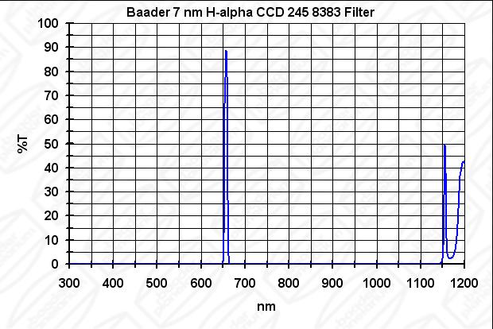 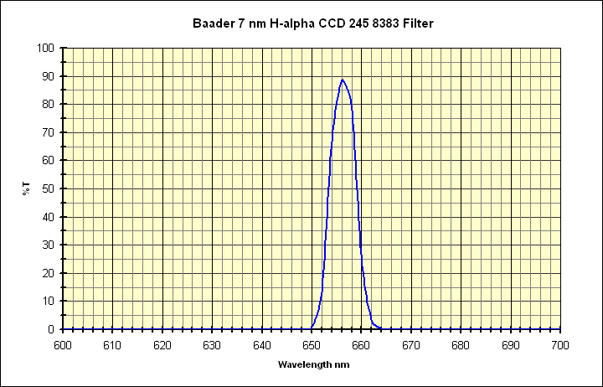

Figure 3: Filter transmission from Baader website, *h_alpha_ccd_7nm_kurve.jpg* (left) and Filter transmission data from Company 7 website, *baader_h-alpha.gif* (right).

#### Measured Data

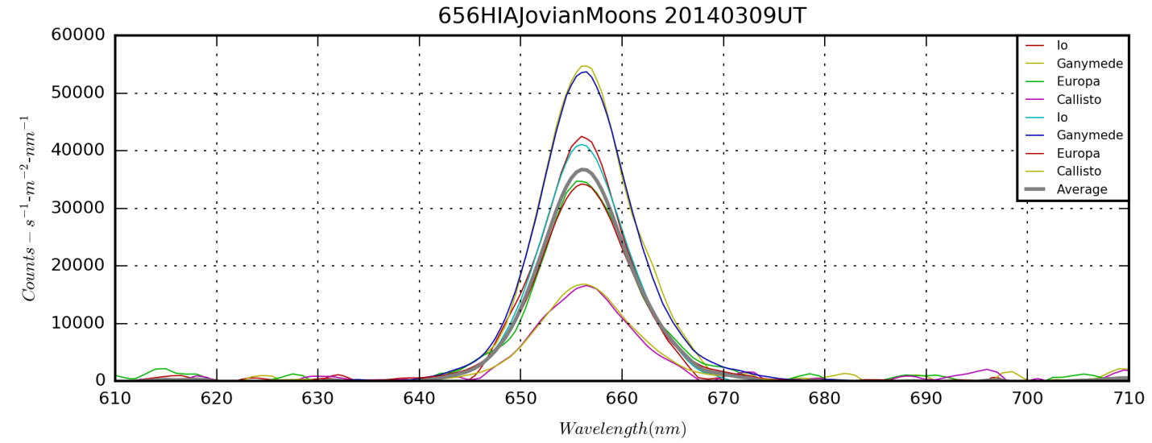

656HIA Jovian Moons NUV 20140309UT_1D.png from *FilterSpectumFromFITS.py*.

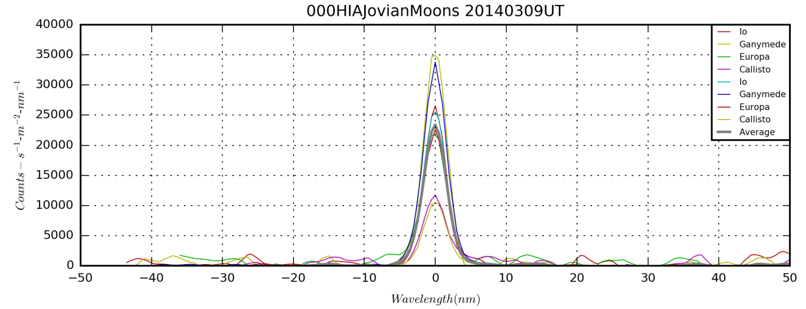

Dispersion=1.0421±0.0003 nm-pix-1

**Target,Date-Time(UT),Band Type,Band,Start(nm),End(nm),Cont(nm), EW/Intensity,Peak,Center(nm)**

**HAL,2014-03-09 00:00:00,Target,656HAL,641.500,670.500,3.500,-404662.775,36836.278,656.446**

Response of the narrowband filters within the bounds of the 656HIA filter are discussed below.

The NII contributions to the HIA filter are approximations. Because the line pair straddles the HIA line and resides on the shoulders of the gaussian response there is reduced to about 0.90 of the peak. Thus, for the 1260mm optics, the sensitivity is 0.90*0.509=0.458. For the 135mm optics the sensitivity is 0.90*0.634=0.571.

NEED TO COMPLETE OR TRANSFER THE MORE DETAILED ANALYSIS OF THIS FILTER. PROBABLY IN AN OBSERVING NOTES REPORT.



NarrowBandFilterCalculations.xlsx under /JovianMoons/SpectralData

#### Adopted Performance

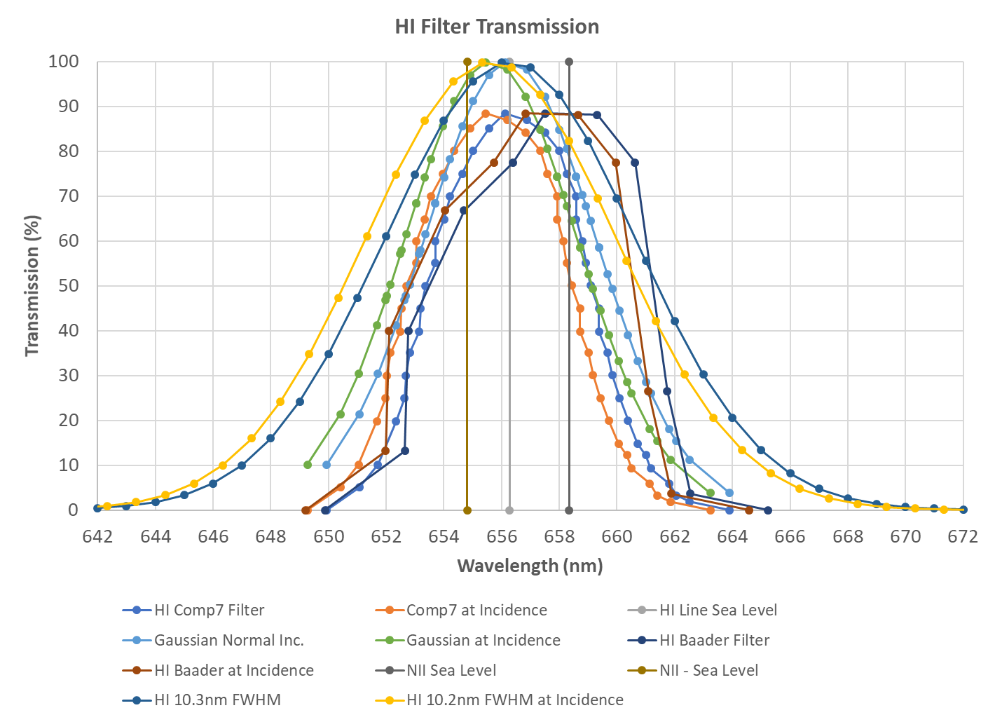

CameraResponse.xlsx

We take model #7 for the transmission properties and multiply the EW and transmissions by the response of the system with the clear filter. Those values are 0.509, 0.509, 0.502, and 0.443 for EW, HIA, NII, and SII.

Table 2: Models and Transmission Parameters.

|  |  |  |  |  |  |  |  |
| --- | --- | --- | --- | --- | --- | --- | --- |
| **Model** | **FWHM** | **Peak** | **Peak Wv.** | $$E^{656HIA}$$ | $$s_{HIA}^{656HIA}$$ | $$s_{NII}^{656HIA}$$ | $$s_{SII}^{656HIA}$$ |
| 7) Measured, 0.88 peak at 656.3 nm | 4.88 | 0.45 | 656.3 | 4.57 | 0.45 | 0.39 | 0.00 |

### 658NII Filter – Astrodon NII 3.0 nm

The discussion of this filter is necessarily a bit complex because of it’s narrowness and the fact of the nearby contaminating Hα line. First, we discuss the manufacturer’s measurements for my filter. Then, prompted by difficulties in differentiating Hα and NII emissions in M42, we investigate second order effects including instrumental focal length and atmospheric pressure.

#### Manufacturer Data

When I purchased the filter on Astromart, the seller provided a paper slip with the transmission measurement of *this* filter from the manufacturer (Figure 5). I scanned the data and digitized it with DataTheif in to a spreadsheet (*CameraResponse.xlsx*). This data shows that the transmission at 658.4 nm is 0.9692 with a peak response of 0.9825. Numerically integrating over the sample points gives an EW of 3.15nm. This is very similar to the result of using AstroDon stock data, which specifies a FWHM 3.0nm. Using this FWHM gives an EW of 1.0645*3.0=3.19nm, assuming peak transmission of unity.

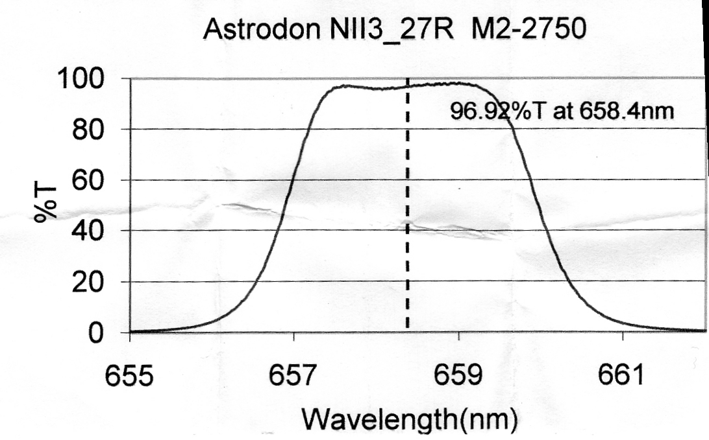

Figure 11: NII filter transmission as measure by AstroDon Inc. (658NII-FilterScan.jpg)

Using the scanned filter transmission and the ST2000 sensitivity in combination with the C8 and Pentax 135mm lens, we find the sensitivity of the peak at 658.4nm is 0.502 and 0.589. This gives continuum equivalent widths of 1.58nm and 1.86nm respectively.

Retrieving a truly pure NII signal means understanding what the contribution is to the observation from contaminating HIA. Linear interpolation of the data at the HIA wavelength of 656.3nm indicates that the 0.1292. The sensitivity at 656.3nm the peak is 0.509 and 0.634 in using the 1260mm and 135mm lenses with the 550CLR filter. Thus, the peak response to HIA with the NII filter transmissions is 0.1292*0.509=0.066 for 1260mm and 0.1292*0.634=0.082 for 135mm.

When these numbers were applied to the retrieval of a pure NII image of M42 using the C8 and ST2000, it was clear something wasn’t right. One would expect the NII image to closely resemble the SII image due to their similar ionization and excitation energies. However, even after subtraction of the HIA signal, the resulting “pure” image was barely distinguishable from the HIA image. To obtain an image that looked “right” required subtracting 50% of the HIA image from the NII image.

#### Second Order Effects

I sought possible causes for this inconsistency. Several candidates were: band shift of the filter due to angle of incidence effects, shift of the line wavelengths due to non-standard atmospheric pressure (elevation at Denver), and line wavelength shifts due to the doppler effect within the source nebula.

I first investigated incidence angle effects. An article hosted on Astrosurf [*Rodríguez*, 2008] provides a quick summary of how to compute the shift in a narrow band filter based on the focal length of the lens. The angle of incidence at the filter is computed as:

$$θ=\tan^{-1}{\frac{D}{2F}}$$

Where *D* is the aperture diameter (0.2032m) and *F* is the focal length. The focal reducer used indicates the focal ratio should be f/6.3, which gives *F*=1.280m and *θ*=4.467deg. However, the plate scale from PinPoint Astrometry solutions is 1.019 arcsec-pixel-1. With 7.4μm pixels, this gives *F*=1.498m and *θ*=3.819deg. The difference is probably due to the back-focus difference from some ideal value with my camera set up.

Once the incidence angle is known, the blue shift can be computed as:

$$λ_{θ}=λ_{0}{\left[1-{\left(\frac{N_{a}}{N_{f}}\right)}^{2}\sin^{2}{θ}\right]}^{1/2}$$

For the refractive index of air we use *Na*=1.0 and for the refractive index of the filter glass we use *Nf*=1.5[3]. For *F*=1.280m the wavelength shift is -0.888nm and for *F*=1.498m the wavelength shift is -0.649nm. Using the 0.649nm shift, we get the transmission of the NII filter at 656.3nm as 0.5982. Thus, the response to HIA with the NII filter transmissions is 0.5982*0.509=0.304 for 1260mm and 0.5982*0.634=0.379 for 135mm.

Second, I investigated the effect of atmospheric pressure in Denver being lower than the STP values for which air wavelengths are usually calculated. Standard sea level pressure is 101.325 kPa, but pressure in Denver is usually near 83.4 kPa. Using a site at NIST’s Engineering Metrology Toolbox[4], we can compute that the vacuum wavelength of HIA (656.48 nm) gives an air wavelength of 656.30 nm at STP. At Denver pressure the air wavelength is 656.334 nm. This is a redshift of about 0.034 nm that would move the line even more into the bandpass of the NII filter. This increases the transmission of HIA through the NII filter from 0.5982 to 0.6329.

Finally, I looked at radial velocity in the Orion Nebula to see if doppler effects are large enough to be important. From [*Weilbacher et al.*, 2015] we find the radial velocity is quite small: -24 < *VR* < +32 km-s-1. The maximum doppler width is Δλ= 656.3×(56/3×105) = 0.123 nm. If we take the mean shift to be +4 km-s-1, then the mean redshift is 0.009 nm.

The final effect very small enough and spatially variable so it is disregarded. The shift in the filter bandpass is shown in Figure 6 with the locations of the HIA 656.3 and NII 658.4 lines shown for reference.

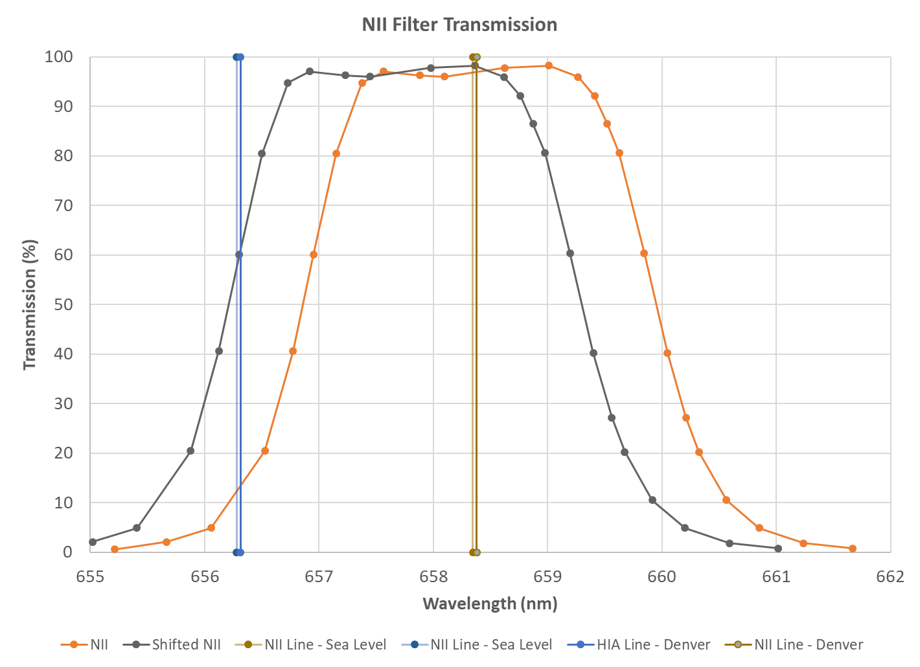

Figure 12: Manufacturer data for my specific NII filter along with wavelength shift for use with C8 and focal reducer.

#### Adopted Performance

Because the line is double and the NII filter only picks up one of the pair, the total sensitivity at 658.4 is multiplied by 0.75. Thus, for the 1260mm optics, the sensitivity is 0.9692*0.75*0.502=0.365.

|  |  |  |  |  |
| --- | --- | --- | --- | --- |
|  | $$E^{658NII}$$ | $$s_{HIA}^{658NII}$$ | $$s_{NII}^{658NII}$$ | $$s_{SII}^{658NII}$$ |
| 1260mm 200lpm | 1.58 | 0.066 | 0.365 | 0.000 |
| 135mm 100lpm | 1.86 | 0.082 | 0.428 | 0.000 |

Table 4: Models and Transmission Parameters.

|  |  |  |  |  |  |  |  |
| --- | --- | --- | --- | --- | --- | --- | --- |
| **Model** | **FWHM** | **Peak** | **Peak Wv.** | $$E^{658NII}$$ | $$s_{HIA}^{658NII}$$ | $$s_{NII}^{658NII}$$ | $$s_{SII}^{658NII}$$ |
| 1) 3 nm FWHM Gaussian, unity peak at 658.4 nm | 3.00 | 1.00 | 658.4 | 3.19 | 0.26 | 0.75 | 0.00 |
| 2) 3 nm FWHM Gaussian, 0.98 peak at 658.4 nm | 3.00 | 0.98 | 658.4 | 3.10 | 0.25 | 0.74 | 0.00 |
| 3) AstroDon Plot | 3.05 | 0.98 | 658.8 | 3.15 | 0.13 | 0.73 | 0.00 |
| 4) AstroDon Plot shifted for ~f/6.3 incidence | 3.05 | 0.98 | 658.2 | 3.15 | 0.61 | 0.74 | 0.00 |

Table 4: Adopted Response Parameters.

|  |  |  |  |  |  |  |  |
| --- | --- | --- | --- | --- | --- | --- | --- |
| **Model** | **FWHM** | **Peak** | **Peak Wv.** | $$E^{658NII}$$ | $$s_{HIA}^{658NII}$$ | $$s_{NII}^{658NII}$$ | $$s_{SII}^{658NII}$$ |
| 4) AstroDon Plot shifted for ~f/6.3 incidence | 3.05 | 0.49 | 658.2 | 1.58 | 0.31 | 0.37 | 0.00 |

### 672SII Filter – Baader Planetarium 8.0 nm

#### Manufacturer Data

The manufacturer data shows the FWHM to be 8.0nm giving an EW of 1.0645*8.0=8.52nm assuming peak transmission of unity. The sensitivity of the peak is 0.443 and 0.559 in using the 1260mm and 135mm lenses with the 550CLR filter. This gives EWs of 3.77 nm and 4.76 nm respectively.

Response of the narrowband filters within the bounds of the 672SII filter are shown below with the continuum equivalent widths computed base on a simple **Gaussian distribution**.

|  |  |  |  |  |
| --- | --- | --- | --- | --- |
|  | $$E^{672SII}$$ | $$s_{HIA}^{672SII}$$ | $$s_{NII}^{672SII}$$ | $$s_{SII}^{672SII}$$ |
| 1260mm 200lpm | 3.77 | 0.000 | 0.000 | 0.443 |
| 135mm 100lpm | 4.76 | 0.000 | 0.000 | 0.559 |

If we look at the transmission profile from the manufacturer, the data gives the EW as 9.46 nm. This gives a FWHM of 8.88 nm. Also, the peak transmission is 0.91 versus the assumption used above of 1.0. This means that the sensitivity of the peak is 0.403 and 0.509 in using the 1260mm and 135mm lenses with the 550CLR filter. This gives EWs of 3.79 nm and 4.82 nm respectively.

|  |  |  |  |  |
| --- | --- | --- | --- | --- |
|  | $$E^{672SII}$$ | $$s_{HIA}^{672SII}$$ | $$s_{NII}^{672SII}$$ | $$s_{SII}^{672SII}$$ |
| 1260mm 200lpm | 3.79 | 0.000 | 0.000 | 0.403 |
| 135mm 100lpm | 4.82 | 0.000 | 0.000 | 0.509 |

The main difference between the Gaussian shape assumption and the “real” shape assumption is a reduction in sensitivity to the SII line emission relative to the continuum sensitivity.

Table 5: Models and Transmission Parameters.

|  |  |  |  |  |  |  |  |
| --- | --- | --- | --- | --- | --- | --- | --- |
| **Model** | **FWHM** | **Peak** | **Peak Wv.** | $$E^{672SII}$$ | $$s_{HIA}^{672SII}$$ | $$s_{NII}^{672SII}$$ | $$s_{SII}^{672SII}$$ |
| 1) 8nm FWHM Gaussian, unity peak at 672.0nm | 8.00 | 1.00 | 672.0 | 8.56 | 0.00 | 0.00 | 0.96 |
| 2) 8nm FWHM Gaussian, 0.91 peak at 672.0 nm | 8.00 | 0.91 | 672.0 | 7.79 | 0.00 | 0.00 | 0.87 |
| 3) Baader Plot | 8.89 | 0.91 | 675.5 | 9.46 | 0.00 | 0.00 | 0.75 |
| 4) Baader at incidence | 8.89 | 0.91 | 674.9 | 9.46 | 0.00 | 0.00 | 0.80 |
| 5) Company7 Plot | 7.12 | 0.91 | 675.7 | 7.58 | 0.00 | 0.00 | 0.69 |
| 6) Company7 at incidence | 7.12 | 0.91 | 675.1 | 7.58 | 0.00 | 0.00 | 0.78 |

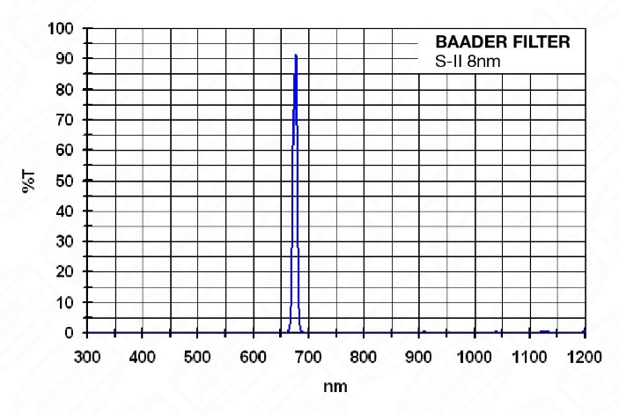 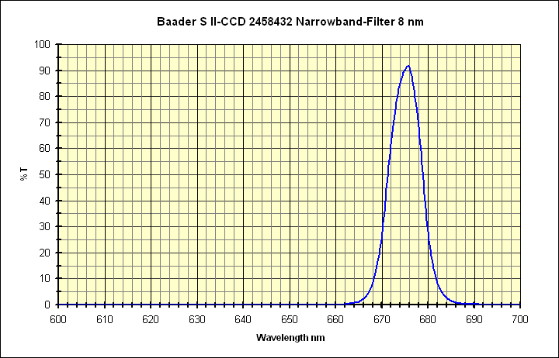

Figure 3: Filter transmission from Baader website, *baader-s-ii-8nm-ccd-narrowband-filter-1-1-4--5b7.jpg* (left) and Filter transmission data from Company 7 website, *baader_SII.gif* (right).

#### Adopted Performance

We have no measured spectral data for SII filter, but we have multiple sets of manufacturer data. Because the two profiles are significantly different in shape and center we adopt the average performance for further analysis. Using the “at incidence” numbers, the results are 8.01 nm, 0.91, 675.0 nm, 8.52 nm, 0.79 for FWHM, Peak, Peak. Wv., EW, and SII response, respectively.

Table 5: Adopted Response Parameters.

|  |  |  |  |  |  |  |  |
| --- | --- | --- | --- | --- | --- | --- | --- |
| **Model** | **FWHM** | **Peak** | **Peak Wv.** | $$E^{672SII}$$ | $$s_{HIA}^{672SII}$$ | $$s_{NII}^{672SII}$$ | $$s_{SII}^{672SII}$$ |
| 4) Baader at incidence | 8.01 | 0.40 | 675.0 | 3.77 | 0.00 | 0.00 | 0.35 |

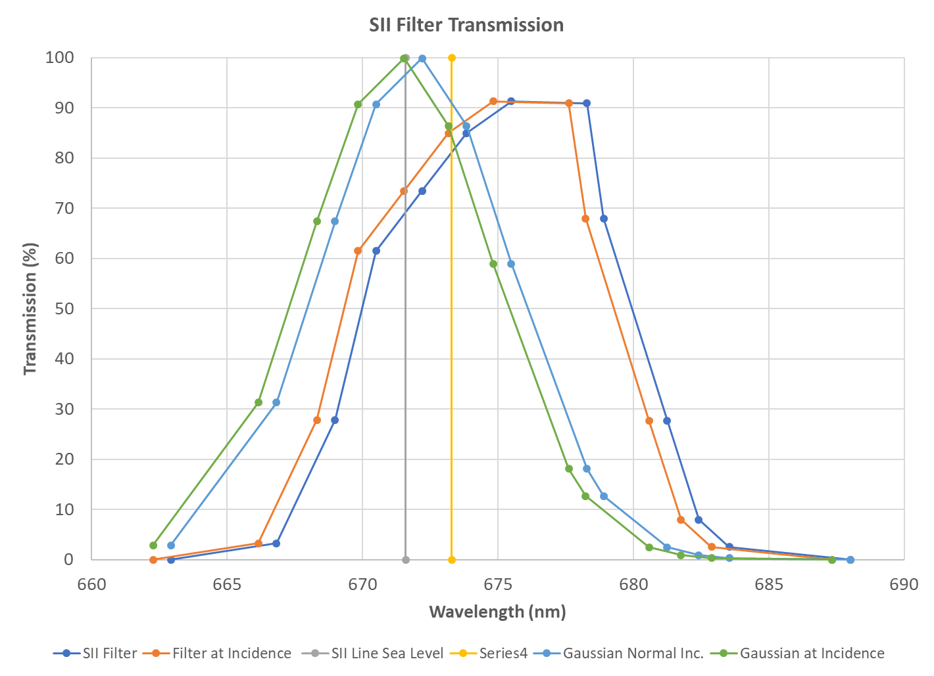

## Photometric Continuum Best Fit

Calibration Environment

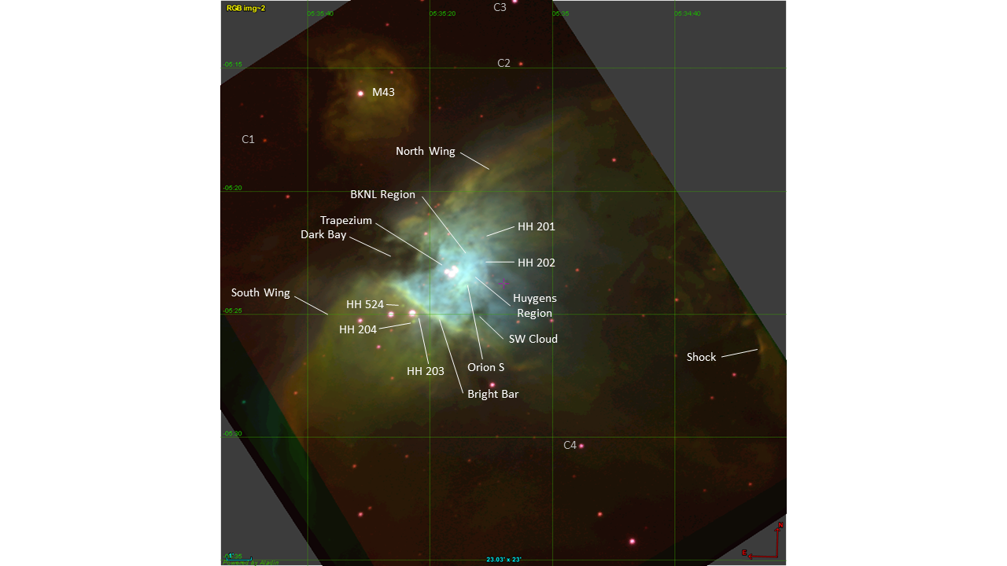

M42 ST2000XM+C8 Observations for RED, HIA, NII, and SII

|  |  |  |  |  |  |
| --- | --- | --- | --- | --- | --- |
| **Label** | **ID** | **Obj. Type** | **Spec. Type** | **Use** | **Notes** |
| C1 | [BRUN 862](http://cdsportal.u-strasbg.fr/?target=Brun%20862) | *iN, *iC, Em* | K3 | No | Emission lines |
| **C2** | [**V2149 Ori**](http://cdsportal.u-strasbg.fr/?target=V2149%20Ori) | **V*, Em\*** | **G0+F7** | **Yes?** | **IR Var. 8.16 - 8.24 J, Emission lines** |
| **C3** | **HD 36981** | **V\*** | **B7III/IV** | **Maybe?** | **Var: 7.76 - 7.89 V** |
| **C4** | **HD 36939** | **V\*** | **B7/8II** | **Maybe?** | **8.97 - 9.03 V, but strong Ha absorp.** |
| C5 | KM Ori | V*, Em* | K5Ve | No | T-Tauri star; 12.3 - 13.8 p |
| C6 | BD-05 1307 | V*, Em* | K2III-IV | No |  |
| **C7** | **The 2 Ori B** |  | **B2-B5** | **Maybe?** | **Saturated in RED** |

M33 ST2000XM+C8 Observations for RED, HIA, and SII

## Final Adopted Transmission and Response

## NIR Regime Filters

### 685NIR Filter – Baader

#### Manufacturer Data

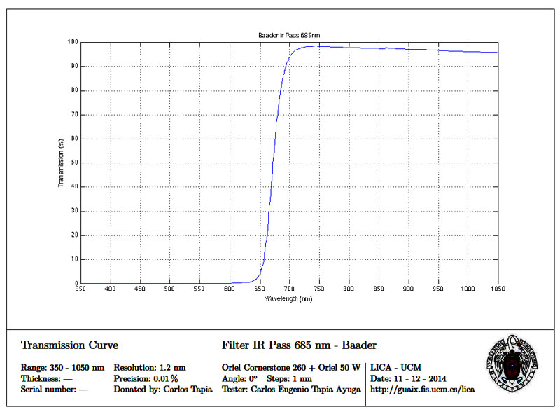

Figure 15: Transmission measured? (IR_685.jpg)

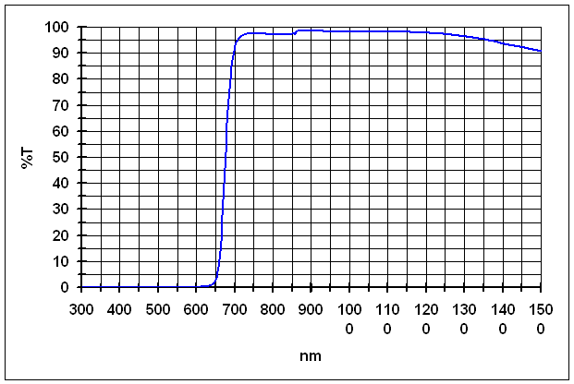

Figure 16: Transmission data from Baader website. (BA58385-b.gif)

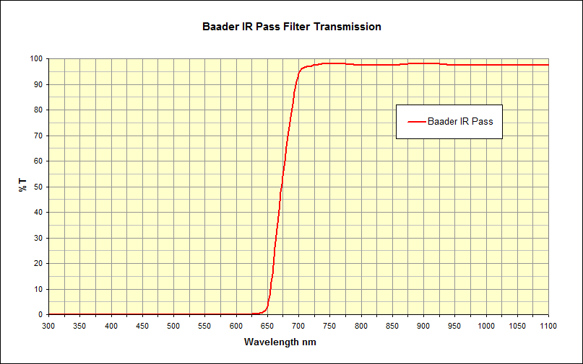

Figure 17: Transmission data from Company 7? (baader_ir_pass.gif)

#### Measured Data

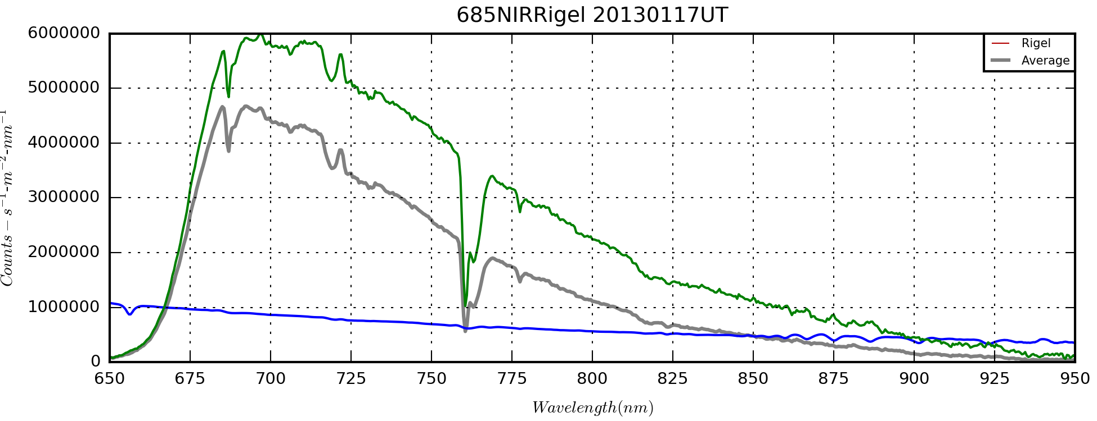

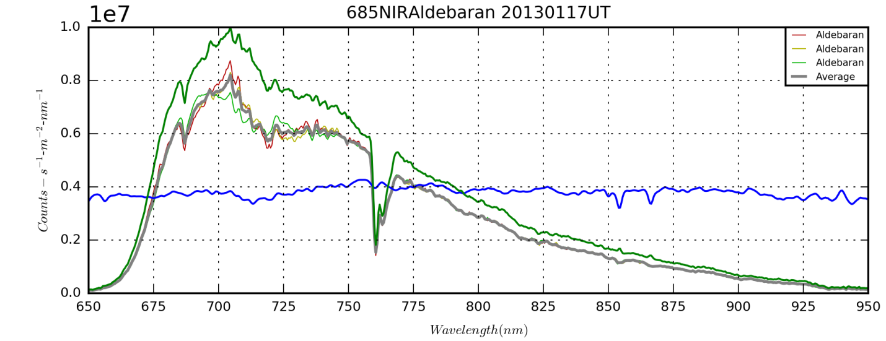

### 730OII Filter – Edmund Optical 10 nm

### 742NIR Filter – Astronomik

#### Manufacturer Data

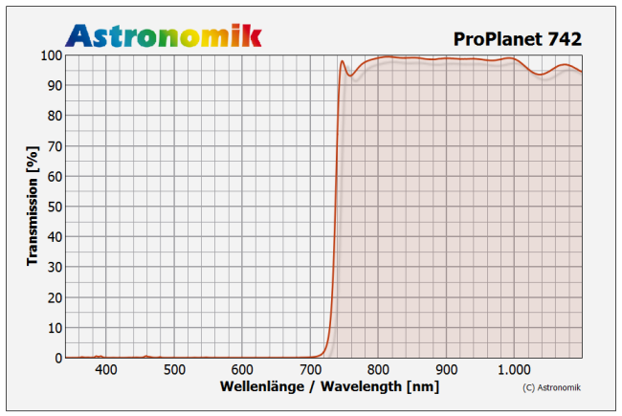

Figure 18: Transmission data from Astronomik website. (astronomik-proplanet-742_trans.png)

#### Measured Data

### 807NIR Filter – Astronomik

#### Manufacturer Data

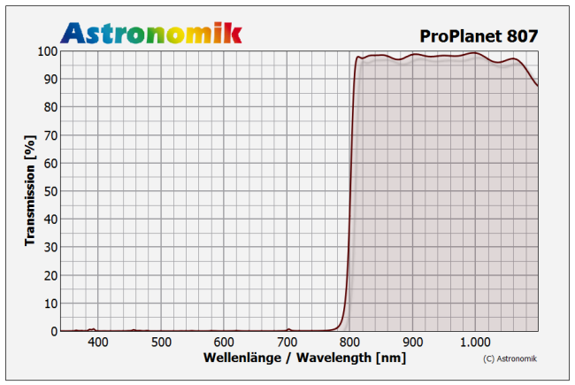

Figure 19: Transmission data from Astronomik website. (astronomik-proplanet-807_trans.png)

#### Measured Data

### 889CH4 Filter – Methane, Model, etc…

#### Manufacturer Data

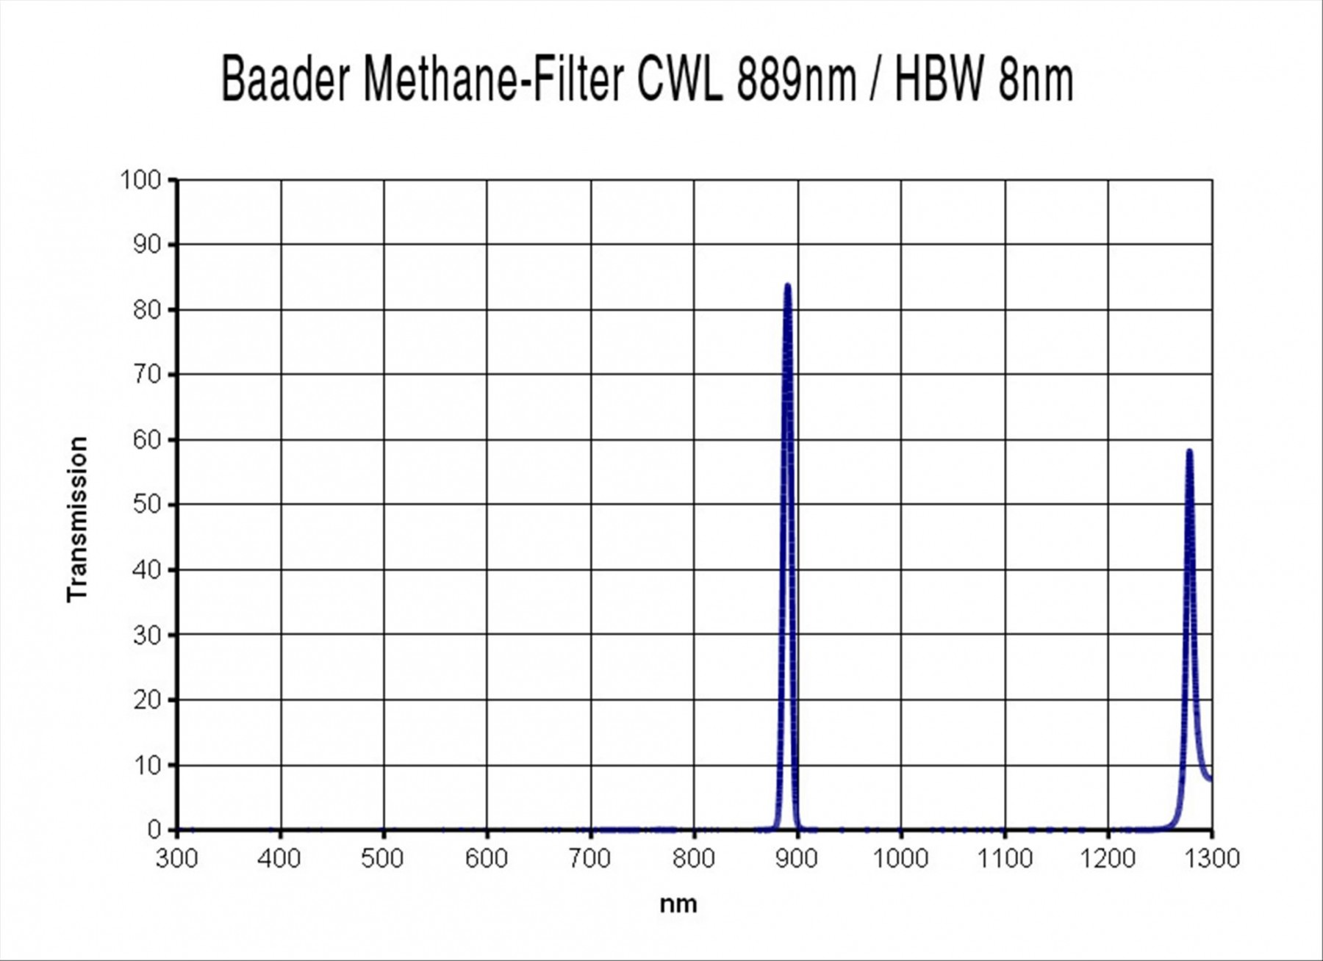

Figure 20: Transmission data from Baader website. (baader-methane-filter-1-1-4-889nm-8nm-acf.jpg)

#### Measured Data

Methane filter spectra with suitable near-point sources are available from 20140309UT. These are co-added, Jupiter-aligned observations with a total integration time of 150 seconds. The Galilean moons serve as the near-point sources. Using Jupiter aligned images does little to blur the moons since the interval over which the images are co-added is small compared to the orbital motion of the moons.

|  |  |  |  |  |  |  |  |  |  |  |  |  |
| --- | --- | --- | --- | --- | --- | --- | --- | --- | --- | --- | --- | --- |
| **Target** | **Date-Time(UT)** | **Band Type** | **Band** | **Start(nm)** | **End(nm)** | **Cont(nm)** | **EW/Intensity** | **Peak** | **Center(nm)** | **Dispersion** | **Disp. Err.** | **FWHM** |
| CH4 | 2014-09-03 | Target | CH4 889 | 875.5 | 904.5 | 3.5 | -11933.4 | 1063.776 | 889.528 | 1.0382 | 0.0094 | 11.21798 |

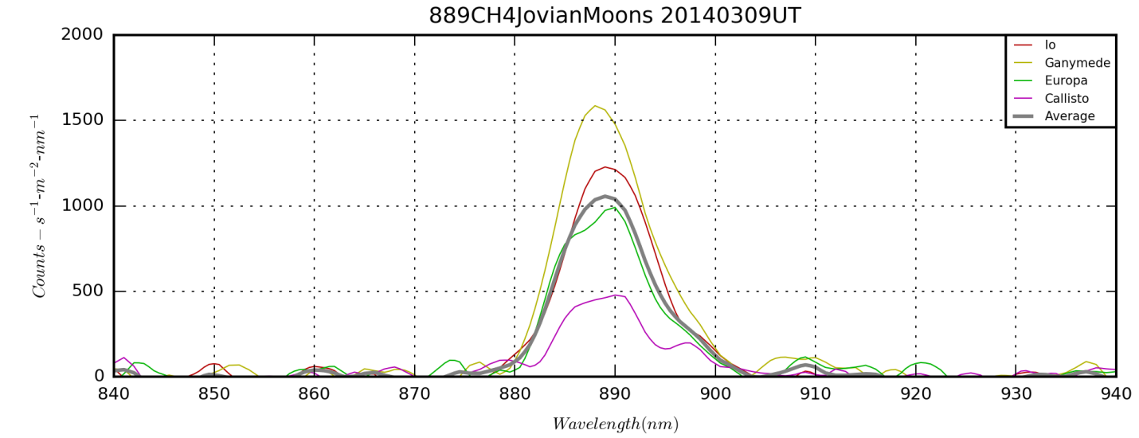

889CH4 Jovian Moons NUV 20140309UT_1D.png from *FilterSpectumFromFITS.py*.

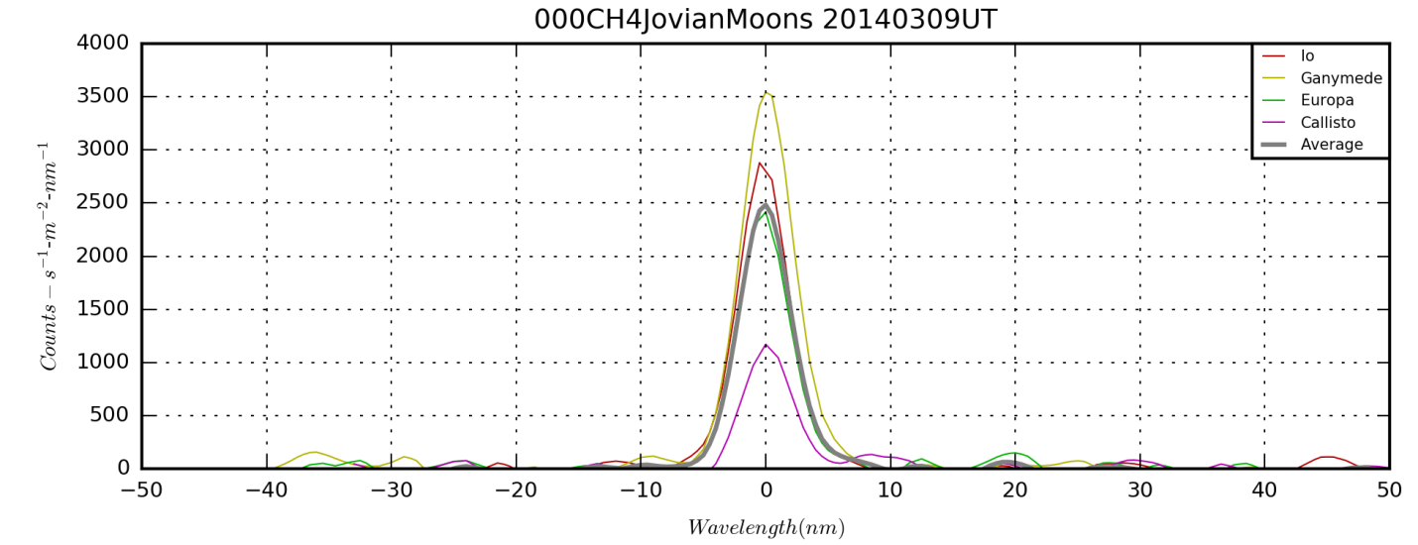

NOTE: Why did I choose Jupiter-Aligned images for this?

FWHM=10.5 nm as measured on screen by mouse. This gives the HIP 11 line at 886.2 nm a relative response of 0.84. The contribution from HIP 10 at 901.5 nm is only about 5.9%.

According to the Buil (maybe non-quantitative?) spectrum, the relative intensity peak for HIP 11 is ~0.015 and the continuum background sits at 0.002 nm-1. The claimed resolution is 800 implying sampling line widths of about 886.2/800~1.1nm. If we treat that as the line’s FWHM, then we have a line EW of ~0.0177nm.

$W_{HIα}^{656}=\sqrt{2π}{∙R}_{HIα}^{656}∙|0.42466∙{FWHM}_{HIα}^{656}|$,

Multiplying by the relative response of the 889CH4 filter at 886.2nm we get a measured contribution of 0.0149 nm.

The EW of the 889CH4 filter (with peak response normalized to 1.0) is 11.22 nm. Thus, the continuum background would contribute about 0.0224 nm EW signal.

ContMean,BandMean= 0.431863164868 411.929080887

Centroid= 889.527697

889.000 1064.2081604

### 940NIR Continuum/CH4 Window Filter – Edmund Optical 10 nm

### 1000NIR Longwave Filter – Edmund Optical >1000nm

I ordered a SCHOTT RG-1000, 25.4mm Dia., Longpass Filter [(#32-760)](https://www.edmundoptics.com/p/rg-1000-254mm-dia-longpass-filter/2579/) from Edmund Scientific on 2/6/2020 for $36.50. A [data sheet](https://microsites.schott.com/d/us-lidar/1f11815a-6def-4b9d-8bf3-e6df0009e3c6/20190925140417/schott-microsites-datasheet-rg1000-english-25092019.pdf) is available online and linked from the Edmund Site and is also downloaded to the F:\Astronomy\Projects\Techniques\Flux Calibration\Filters folder. One chart is copied below for convenience.

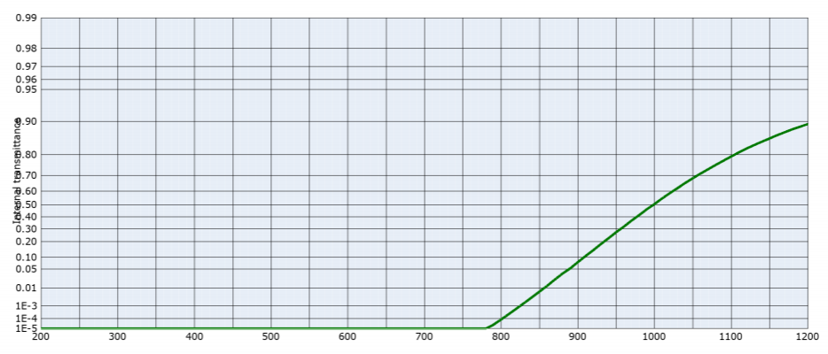

## Other Filters

### Lumicon Deep Sky Filter

#### Manufacturer Data

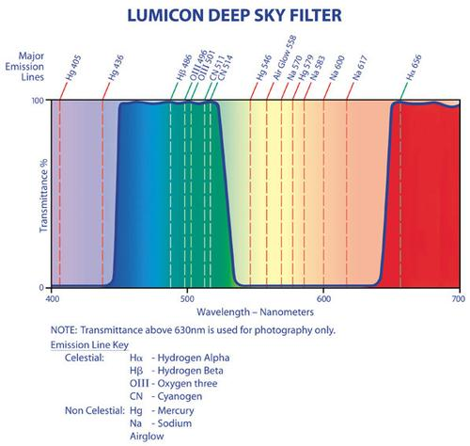

LumiconDeepSkyFilterProfile from OPTCORP.jpg

<https://optcorp.com/products/lumicon-deep-sky-filter-1-25inch-lf3010>

## Appendix: Optical System Details

The goal is to create a master response file as a function of wavelength for each optics-camera-filter system. To do this, known spectra of calibration stars are deconvolved with observed spectra. The observations through the ‘system’ also include the transmission of the atmosphere and the grating efficiency.

Available observations of targets with reliable and stable references spectra are shown in the table below.

Q: What reference observations and reference spectra am I using?

A:

1260mm, f/6.3, 200LPM? Or, is some of this 100LPM?

Filters: Aldebaran, Rigel, Others?

Photometric Vega data from 20110819UT?

Q: What are the units of the reference spectra I’m using?

A: Reference spectra are those provided with RSPEC software, which are in fact those from Pickels, 1998.[5] The spectra are normalized to unity at “approximately” 555.6 nm. Some information is provided on convolving spectra with photometric filters and converting to magnitude in the paper. But, what I also want is a way to scale the model spectra to flux per nm.

Q: What is the first order efficiency of both the 100LPM and 200LPM gratings? Can it be determined from the blaze angle? Can it be inferred from the zero-order and second order signals? Can it be confirmed by photometric imaging in broadband filters?

A:

Q: How should the response be expressed as different factors, e.g., normalized overall transmission x normalized filter transmission x absolute photometric calibration (effective area) x gain?

A:

$$R_{tel+cam}^{filter}(λ)={T^{filter}(λ)R}_{tel+cam}(λ)=S_{cam}^{filter}(λ)/F_{ref}(λ)$$

One ultimately wants $R_{tel+cam}^{filter}(λ)$, the response of the filter-telescope-camera system in terms of DN-erg-1 as a function of wavelength. If you only have $S_{cam}^{filter}$, then you must use a reference spectrum, $F_{ref}(λ)$. This is somewhat problematic because the model flux may vary in important ways from the real source observed. In addition, the model flux is almost always the source flux and does not account for telluric absorption. This means the resultant response, $R_{tel+cam}^{filter}$, includes atmospheric absorption.

Alternatively, if one has both $S_{cam}^{filter}$ and $S_{cam}$, one can compute $T^{filter}$ directly as:

$$T^{filter}=S_{cam}^{filter}/S_{cam}$$

In this case, one gets the filter transmission directly without reliance on a flux model. The filter transmission then can be combined as an independent factor with the response of other telescope-camera systems to yield filter-telescope-camera responses.

A linear and log version of FluxCalibrationYears.png are presented below (computed on 1/23/2018). They use data obtained on Vega, Rigel and Aldebaran. I need to specify configurations here and what the actual data sets are. I believe this may be the 135mm lens!

### Response at Spectral Lines and Windows

Table 6: Relative response of various optics-filter combinations. (ResponseCalibrations20180208.xlsx)



The average response at a line or for a window is computed is computed as:

The values of λ0 and λn are selected to cover the majority of the flux contributing to a window. For a line, they are chosen to be 1 nm wide. THIS IS PROBABLY A BAD IDEA. TOO MUCH DEPENDENCE ON ONE OR TWO SPECTRAL BINS. NOT ONLY THAT, BUT ARTIFACTS FROM THE LINE IN THE MEASURE SPECTRA MAY HAVE A SIGNIFICANT EFFECT.

### Celestron 11

From the Celestron website[6], the clear aperture is stated to be 11 inches (0.2794 m) with a central obstruction of 3.75 inches (0.09525 m). The **resulting aperture is 0.05419 m2**. It would be wise to measure both the correcting plate aperture and the central obstruction to verify these parameters.

### Celestron 8

From the Celestron Manual[7], the clear aperture is stated to be 8 inches (0.2032 m) with a 12% (more precisely 11.82%) obstruction (2.75 inches). The **resulting aperture is 0.02860 m2**. It would be wise to measure both the correcting plate aperture and the central obstruction to verify these parameters.

To obtain the true effective area, which is wavelength dependent, one would need the transmission and reflectivity of the optical elements. This information does not appear to be available in Celestron documentation, but should be a measurable parameter using calibration stars.

Data on Celestron transmission is available at the Starlight XLT page[8]. These data need to be digitized with DataThief and made available to my performance software.

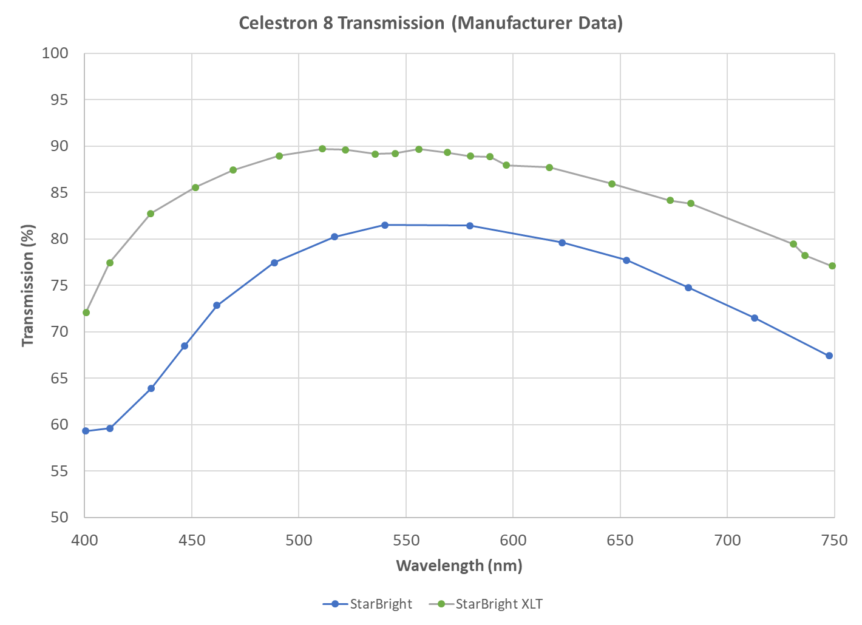

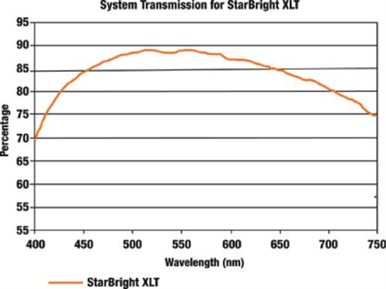

2_System_Transmission_500x374.jpg

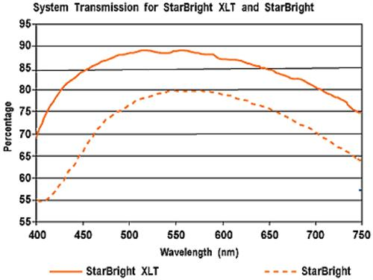

3_System_Transmission_500x375.jpg

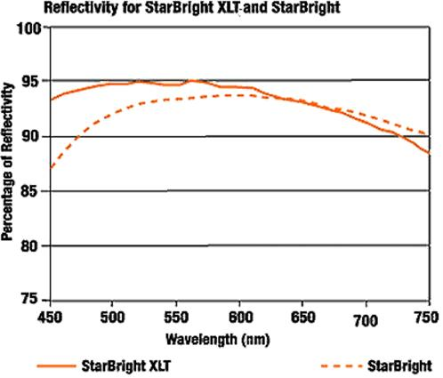

4_Reflectivity_498x425.jpg

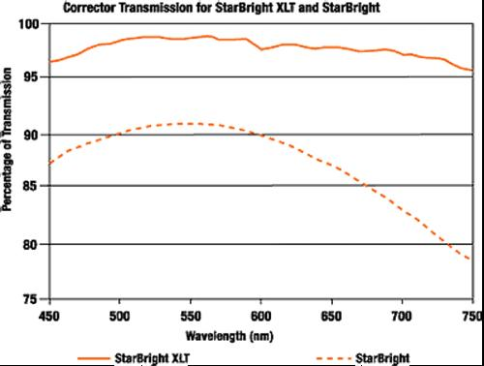

5_Corrector_Transmission_500x378.jpg

### Takahashi TKE Epsilon 130

Last Updated 10/10/2016

Good collimation link:

<http://garyseronik.com/a-beginners-guide-to-collimation/>

Aperture and obstruction link: <https://cloudbreakoptics.com/blogs/news/product-review-takahashi-epsilon-130d>

It indicates that the mirror is oversized at 166mm in diameter so that the instrument has a “true” f/3.3 focal ratio and the obstruction need not be considered. I interpret this to mean that A=πr2, where r=130/2=65mm. If this interpretation is correct, then A=**0.01327 m2**.

### Pentax 135mm Lens

The aperture of the 135 mm lens is dependent of the focal ratio (f) setting (since the focal ratio is controlled by stopping down the aperture) and the use of an objective grating. Without using an objective grating, the area may be expressed as A=π(0.0135/f)2. Examples of aperture for different f-stops are shown in the table below.

|  |  |
| --- | --- |
| **f-stop** | **Aperture (m2)** |
| 22.0 | 2.957E-05 |
| 16.0 | 5.591E-05 |
| 11.0 | 1.183E-04 |
| 8.0 | 2.237E-04 |
| 5.6 | 4.564E-04 |
| 4.0 | 8.946E-04 |
| 2.5 | 2.290E-03 |

For the special case of a 1.25 inch objective grating, which has a clear aperture of ~27 mm, we have an aperture area of 5.726E-04 m2.

## Appendix: Camera Response

### Camera Comparisons

I sampled the plots of QE for two of my cameras every 50 nm and plotted them in Excel (Figure 7) so they could be directly compared. The first interesting thing is to see the significantly higher QE of the ASI120MM CMOS camera versus the older ST2000XM CCD camera. In addition, the ASI120MM has better relative sensitivity in the red end of the spectrum.

However, it’s important to note that the pixel size on the 120MM is half the size of that on the ST2000. That means that you have one quarter of the collecting area. So, it’s important to match the plate scale to the seeing and the resolution goal.

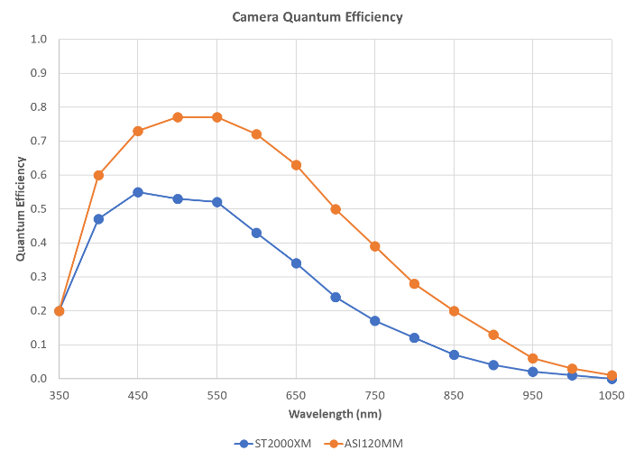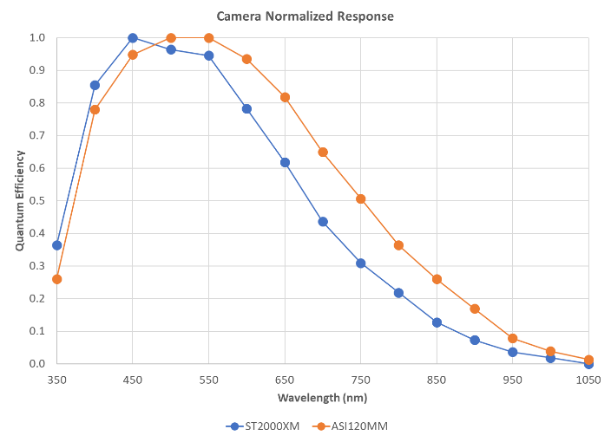

Figure 21: ST2000 and ASI120 quantum efficiency (left) and relative response (right). (CameraResponse.xlsx)

### ST2000XM Model Data

Last Updated 4/4/2016

Quantum efficiency (QE) data for the ST-2000XM with the KAI-2001M detector from 400 to 1000nm was obtained from two sources and is shown in Figure 8. Both show nearly identical values. A screen capture of the right plot was made and saved as *ST2000XM-QuantumEfficiency.PNG*. Then *DataTheif* was used to digitize the plot at 25nm intervals.

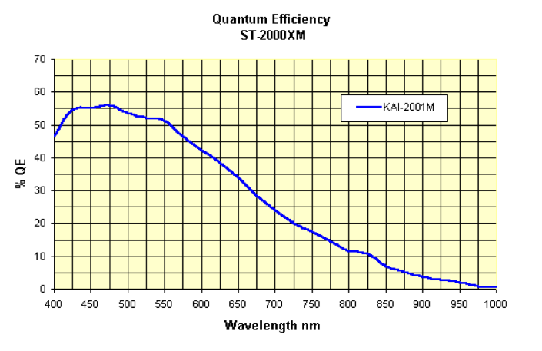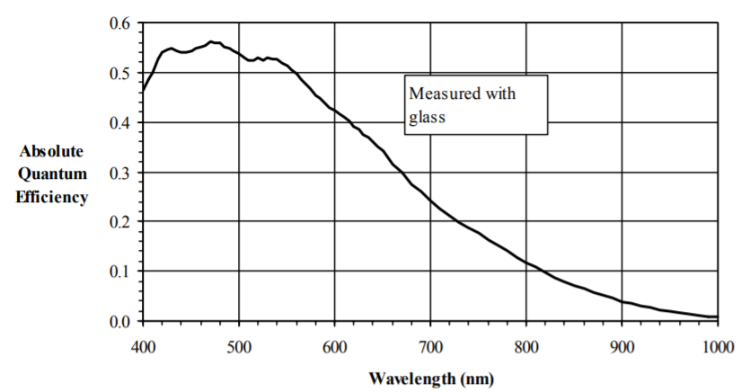

Figure 22: Quantum efficiency plot from the Diffraction Limited website[9] (left), Quantum efficiency plot from Figure 9 in a Kodak report [*Kodak*, 2006] (right).

The available data suggest, but don’t specify, significant quantum efficiency below 400nm. I was able to locate a plot (*qe_st2000UV.gif*) from a German SBIG website[10] that compared the KAI-2001M performance to the UV enhanced KAI-2001UV detector Figure 9. *DataTheif* was used to digitize that plot at 25nm intervals.

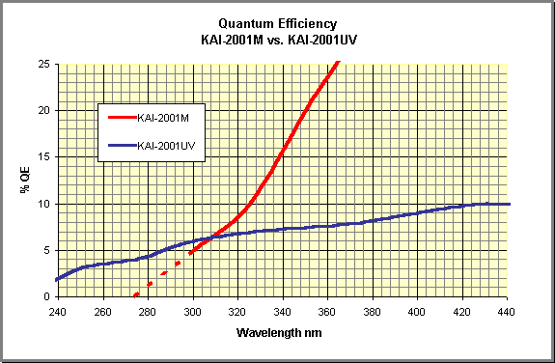

Figure 23: Quantum efficiency below 360 nm.

The data was loaded into the spreadsheet *CameraResponse.xlsx* with the notable exception of the point at 375 nm, which is not available in any of the plots. The QE at 375 nm was computed by linear interpolation. The resulting QE data are plotted (Figure 10), along with a normalized version of the QE (Figure 11), which is effectively relative spectral response. Both values are also presented in Table 3.

|  |  |  |  |  |  |  |  |  |  |  |  |  |  |  |  |  |  |  |  |  |  |  |  |  |  |  |  |  |  |  |  |  |  |  |  |  |  |  |  |  |  |  |  |  |  |  |  |  |  |  |  |  |  |  |  |  |  |  |  |  |  |  |  |  |  |  |  |  |  |  |  |  |  |  |  |  |  |  |  |  |  |  |  |  |  |  |  |  |  |  |  |  |  |  |
| --- | --- | --- | --- | --- | --- | --- | --- | --- | --- | --- | --- | --- | --- | --- | --- | --- | --- | --- | --- | --- | --- | --- | --- | --- | --- | --- | --- | --- | --- | --- | --- | --- | --- | --- | --- | --- | --- | --- | --- | --- | --- | --- | --- | --- | --- | --- | --- | --- | --- | --- | --- | --- | --- | --- | --- | --- | --- | --- | --- | --- | --- | --- | --- | --- | --- | --- | --- | --- | --- | --- | --- | --- | --- | --- | --- | --- | --- | --- | --- | --- | --- | --- | --- | --- | --- | --- | --- | --- | --- | --- | --- | --- | --- | --- |
| Figure 24: ST2000XM Quantum Efficiency. | Table 5: ST2000XM Quantum Efficiency   |  |  |  | | --- | --- | --- | | Wavelength (nm) | ST2000XM QE | ST2000XM Norm. QE | | 275 | 0.0006 | 0.00 | | 300 | 0.0487 | 0.09 | | 325 | 0.0963 | 0.17 | | 350 | 0.1982 | 0.35 | | 375 | 0.3306 | 0.59 | | 400 | 0.4629 | 0.83 | | 425 | 0.5465 | 0.98 | | 450 | 0.5522 | 0.99 | | 475 | 0.5587 | 1.00 | | 500 | 0.5346 | 0.96 | | 525 | 0.5209 | 0.93 | | 550 | 0.5121 | 0.92 | | 575 | 0.4640 | 0.83 | | 600 | 0.4222 | 0.76 | | 625 | 0.3820 | 0.68 | | 650 | 0.3379 | 0.60 | | 675 | 0.2841 | 0.51 | | 700 | 0.2407 | 0.43 | | 725 | 0.1989 | 0.36 | | 750 | 0.1741 | 0.31 | | 775 | 0.1452 | 0.26 | | 800 | 0.1163 | 0.21 | | 825 | 0.1067 | 0.19 | | 850 | 0.0681 | 0.12 | | 875 | 0.0497 | 0.09 | | 900 | 0.0360 | 0.06 | | 925 | 0.0280 | 0.05 | | 950 | 0.0184 | 0.03 | | 975 | 0.0080 | 0.01 | | 1000 | 0.0072 | 0.01 | |
| Figure 25: ST2000XM Normalized Quantum Efficiency |

One possible significant question revolves around whether the detector cover glass is present in the quantum efficiency data presented. According to *Kodak* [2006], the QE from 400 to 1000 nm includes the cover glass. The plot for below 400 nm does not indicate whether or not the cover glass is in place. However, Figure 34 of *Kodak* [2006] provides the cover glass transmission. This figure indicates that the transmission decreases steeply to zero from 350 nm to 310 nm. That would contradict the ~5% QE shown at 300 nm. This may warrant further investigation and refinement in the future.

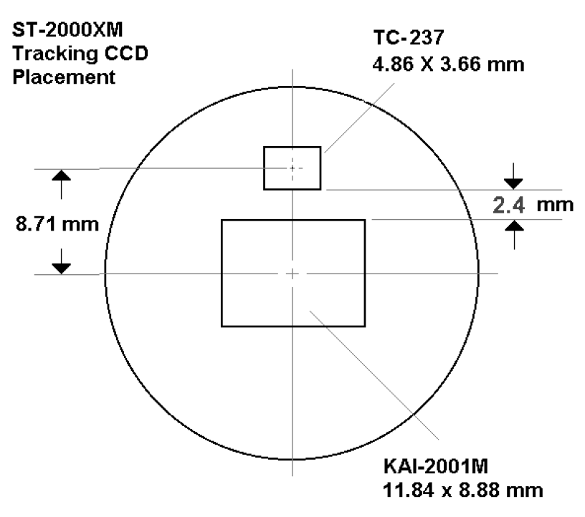

From CCDPlacement.pdf in AppNoteArchive.zip which is available at:

<https://diffractionlimited.com/support/sbig-archives/>

### ASI120MM – ZWO Source Data

Last Updated 4/4/2016

I attempted to conduct ASI120MM photometric measurements on Neptune and Triton in the fall of 2017, but found significant challenges in the consistency of measurements across multiple nights. So I decided to build out this section of this report to at least gather references, specified performance and list identified challenges. The key factory performance data is contained in the ASI120MM manual [*Suzhow ZWO CO.*, 2017]. In addition, a software operation manual [*Suzhou ZWO CO.*, 2017] provides supporting information on how the camera functions.

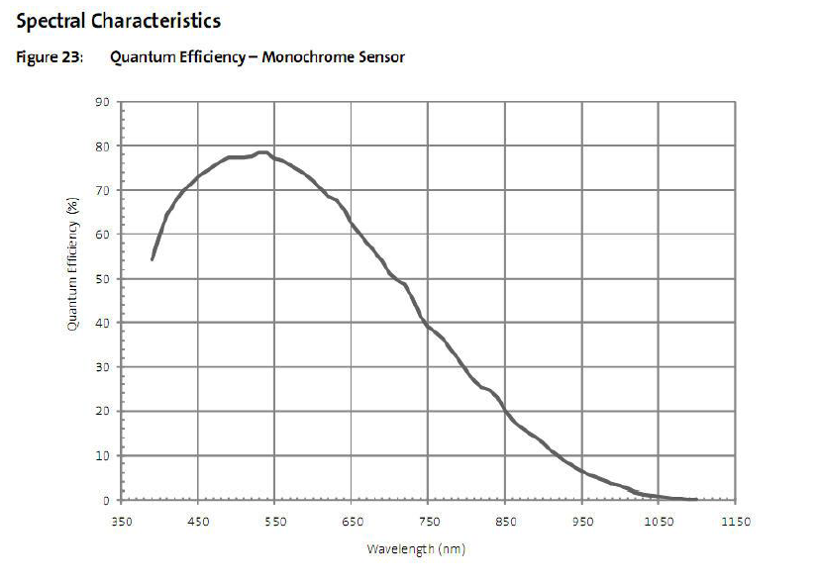

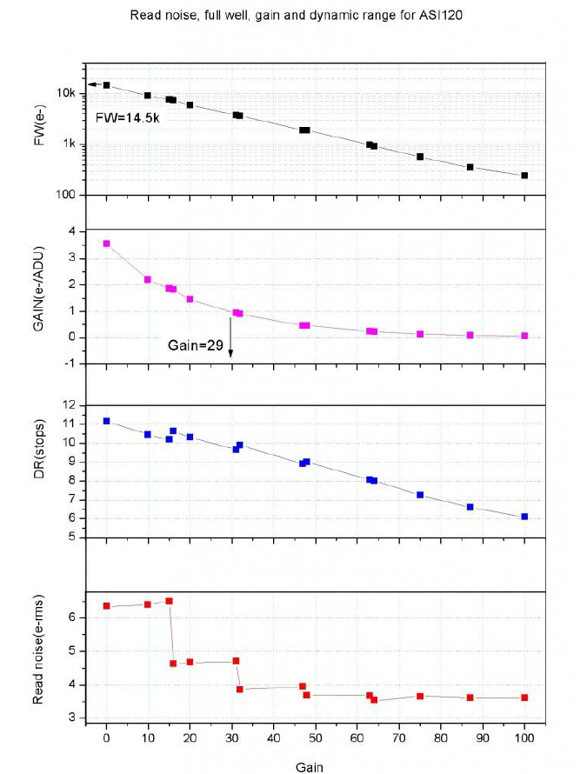

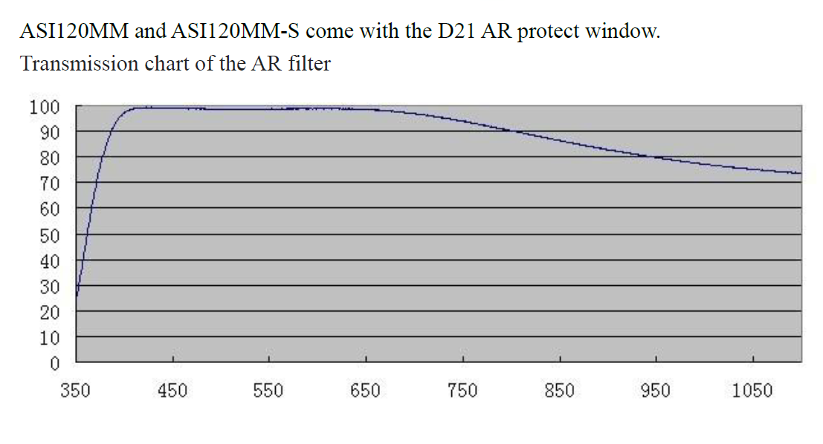

From e-mail dated 4/11/15[11]:

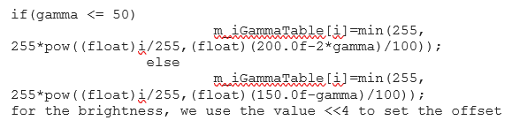

From e-mail dated 4/12/15:

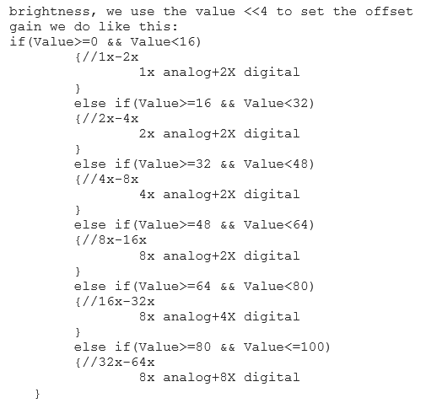

### Canon EOS Rebel 500D

Last Updated 4/4/2016

### ToUCam 840K

Last Updated 4/4/2016

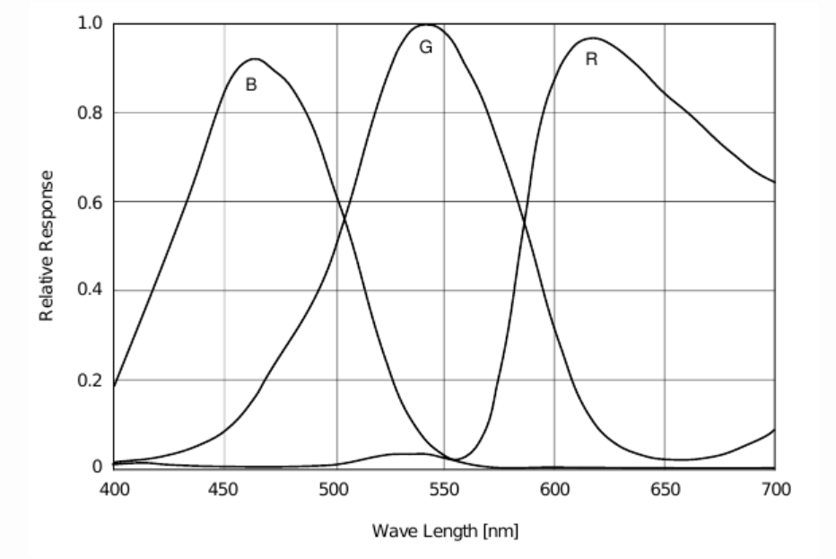

## Appendix: SBIG Filter References

sbig_rgb_filters.gif

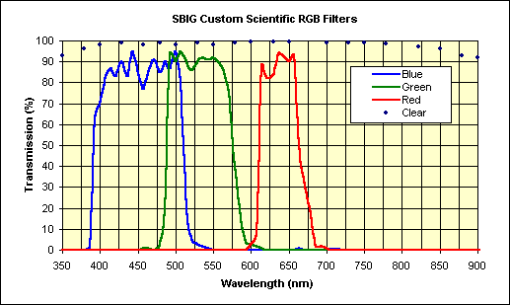

[**http://archive.sbig.com/sbwhtmls/announcement_custom_filters.htm**](http://archive.sbig.com/sbwhtmls/announcement_custom_filters.htm)

*This RGBC filter set is the standard SBIG set that comes with the*[*CFW8A filter wheel*](http://archive.sbig.com/products/cfw8a_new.htm)*and is intended for use with the ST-7/8/9/10/2000 cameras.   The set is also available separately.  It is designed to give a proper balance of continuum light from stars and proper ratios of H-alpha and [O-III] emission line sources (e.g., bright nebula and planetary nebula) at the same time.  These professional quality, high transmission, dichroic filters have been tested over time by some of the best astroimagers in the world.  Many of the remarkable images seen in the gallery of Sky & Telescope and Astronomy magazines have been taken with this filter set and an "ST" series camera.  The colored filters are parfocal, antireflection coated and IR blocked.  The clear filter is AR coated only.  Click here for*[*current prices*](http://archive.sbig.com/sbwhtmls/Pricelist.htm#Section XI)*.*

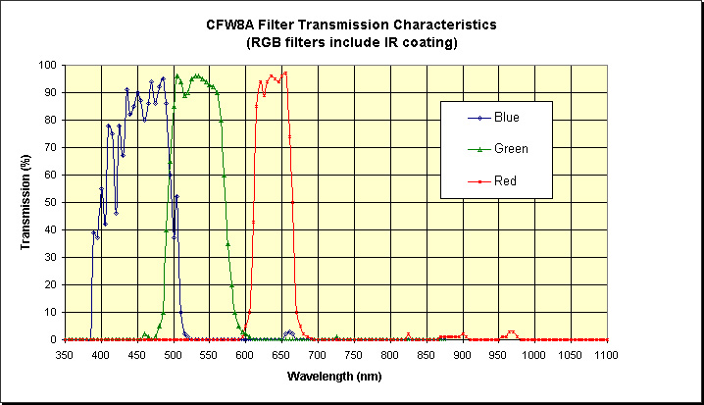

RGB_Filtercurves_newCFW8A.jpg – I’m not sure of the web origin of this plot from SBIG.

## Appendix: Atmospheric Transmission

A significant contributor to measure system performance is wavelength dependent absorption by the atmosphere. While there are many sources for atmospheric measurements and models, I chose data associated with the aTmCam [*Ting Li et al.*, 2014; *T. Li et al.*, 2016] for its thoroughness, appropriate spectral resolution, and recentness. I did not seek digital sources of the data, but instead used DataTheif to manually pick points from an image (Figure 8) at the project web site[12]. I picked points at the average water density of 4 kg-m-2.

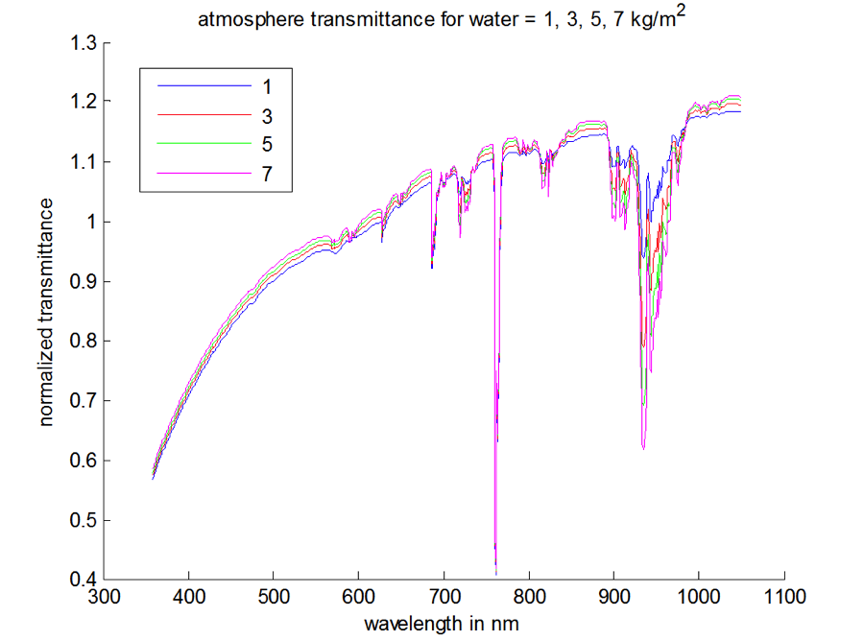

Figure 26: Atmospheric transmission from the aTmCam. (Image1-aTmCam.png)

The data were loaded into the CameraResponse.xlsx spreadsheet and renormalized to the maximum transmittance in the NIR. (The original data appear to be normalized at about 600nm.) The original and renormalized data are plotted in Figure 9.

The 30% drop in transmission from 600nm to 400nm is a significant contributor to both continuum and line response in the blue and NUV regimes of the spectrum. The O2 and H2O absorptions in the visible and NIR are important considerations when assessing nearby emissions. The transmission is dependent on environmental conditions including humidity and visibility. Research I did on the dependence of telluric molecular absorptions on preciptitable water vapor (PWV) and atmospheric pressure is documented in the report *2014 Observing Notes[13]* [*Hill*, 2018] and supporting spreadsheets[14].

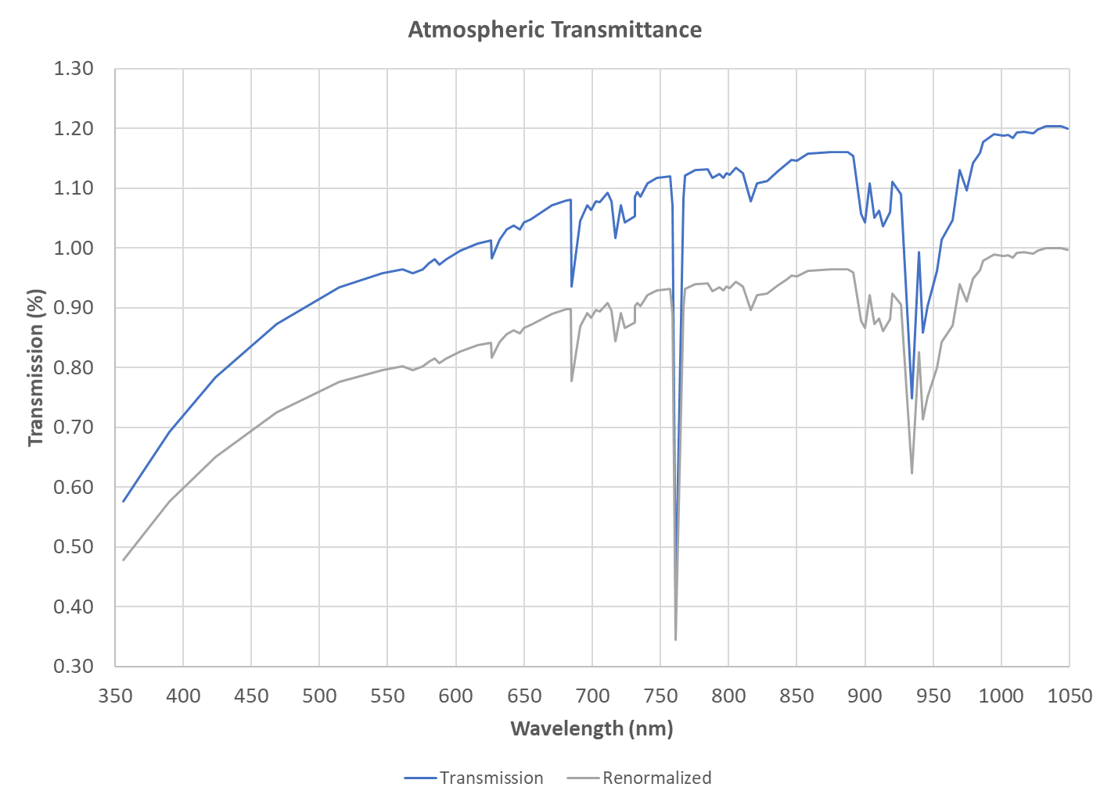

Figure 27: Original and renormalized aTmCam atmospheric transmittance.

## Appendix: Math Stuff and FWHM to EW

Knowing the integral of a Gaussian pass band[15], we can compute the equivalent width of the filter convolved with the system response as:

$W_{HIα}^{656}=\sqrt{2π}{∙R}_{HIα}^{656}∙|0.42466∙{FWHM}_{HIα}^{656}|$, i.e., $W_{HIα}^{656}=1.0645{∙R}_{HIα}^{656}∙|{FWHM}_{HIα}^{656}|$,

which, given that FWHM=8.5 according to vendor literature, further simplifies to approximately:

$$W_{HIα}^{656}=9.048{∙R}_{HIα}^{656}=4.705$$

This work was originally done in *ObservingNotes2016.docx*, so refer there to pull over further details and variable definitions.

Standard deviation ~ FWHM / 2.35482

## Bibliography

Hill, S. (2018), 2014 Observing Notes*Rep.*

Kodak (2006), KODAK KAI-2001 IMAGE SENSOR*Rep. Revision 2.0 MTD/PS-0609*.

Li, T., D. L. DePoy, J. L. Marshall, D. Q. Nagasawa, D. W. Carona, and S. Boada (2014), Monitoring the atmospheric throughput at Cerro Tololo Inter-American Observatory with aTmCam, in *Ground-based and Airborne Instrumentation for Astronomy V*, edited.

Li, T., et al. (2016), aTmcam: A Simple Atmospheric Transmission Monitoring Camera For Sub 1 Percent Photometric Precision, in *The Science of Calibration*, edited by S. Deustua, p. 25.

Rodríguez, I. a. O. L. (2008), Narrow band Filters*Rep.*, <http://www.astrosurf.com>.

Suzhou ZWO CO., L. (2017), ASI Cameras Software Manual

Windows Platform*Rep.*

Suzhow ZWO CO., L. (2017), ASI120 Manual*Rep.*

Weilbacher, P. M., et al. (2015), A MUSE map of the central Orion Nebula (M 42), *Astronomy and Astrophysics*, *582*.

1. These codes are under configuration control in GitHub under the Spectroscopy repository.
2. This code is part of the Techniques repository on GitHub.
3. This is an approximation since we don’t know the actual glass used. The probable range of the index of refraction is 1.51 to 1.53 for BK7 crown glass (<https://refractiveindex.info/?shelf=3d&book=glass&page=BK7>) .
4. <https://emtoolbox.nist.gov/Wavelength/Ciddor.asp>
5. Pickles, A. J. (1998), A Stellar Spectral Flux Library: 1150-25000 Å, *Publications of the Astronomical Society of the Pacific*, *110*, 863-878.
6. <https://www.celestron.com/products/c11-a-xlt-cge-optical-tube-assembly>
7. <http://downloads.celestron.com/Archives/Telescopes/Classic_Orange_Tubes/Orange_Tube_C-5_C-8.pdf>
8. <https://www.celestron.com/pages/starbright-xlt-optical-coatings>
9. <http://diffractionlimited.com/support/sbig-archives/> file AppNoteArchive.zip. The individual file containing this plot is *quantum_20efficiency.pdf*, renamed to SBIG-*quantum_efficiency.pdf* in my files for clarity. The plot shown in was obtained from the extracted file *SBIG-quantum_efficiency.pdf*.
10. <http://www.sbig.de/sbig-history/htm-sbig/quanten.htm>
11. Note that code the two code snippets in this section needed to be inserted as images because some of the character sequences were being interpreted as Word field codes and interfered with EndNote references.
12. <http://instrumentation.tamu.edu/aTmCam.html>
13. Earth Atmosphere and Vega (Spectroscopy) sections
14. *EarthAtmosphereSpectralAnalysis2014.xlsx* and *Mars+Saturn_SpectralAnalysis2014.xlsx*
15. Wikipedia contributors, "Gaussian function," *Wikipedia, The Free Encyclopedia,* <https://en.wikipedia.org/w/index.php?title=Gaussian_function&oldid=704595135> (accessed February 26, 2016).